School Name
Mathematics Test 2017
Year 9 |  | Coordinate Geometry | Calculator Allowed
Skills and Knowledge Assessed:  - Find the distance between two points located on a Cartesian plane using a range of strategies, including graphing software (ACMNA214)  - Find the midpoint and gradient of a line segment (interval) on the Cartesian plane using a range of strategies, including graphing software (ACMNA294) |  |  | Name_________________
Section 1 Short Answer Section
Write all working and answers in the spaces provided on this test paper.

 | 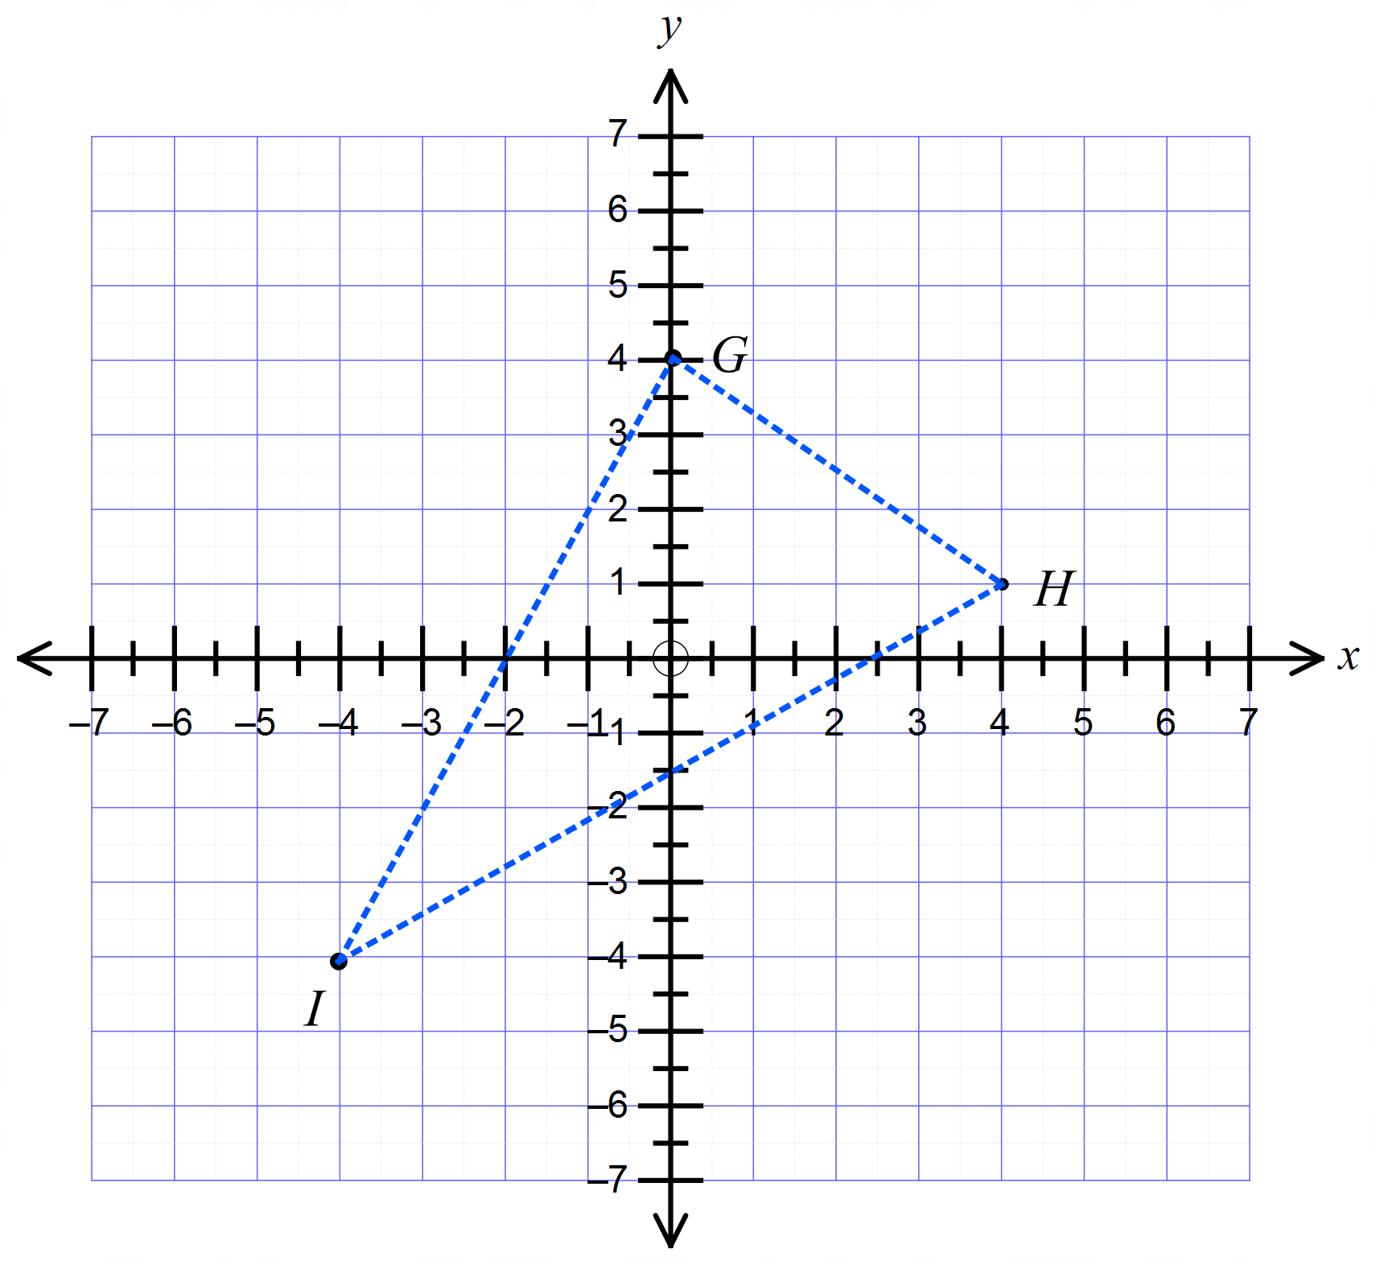Question 1 – 5 refer to the number plane shown.
Write down the coordinates of the points G, H and I ?

……………………………………………………………………………………………….
 | Plot and label the points 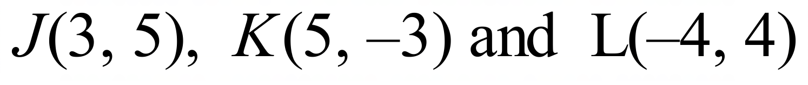 on the number plane above.
What is the distance GH ?

……………………………………………………………………………………………….

……………………………………………………………………………………………….
What is the midpoint of the interval HI ?

……………………………………………………………………………………………….

……………………………………………………………………………………………….
What is the gradient of the interval GI ?

……………………………………………………………………………………………….

……………………………………………………………………………………………….
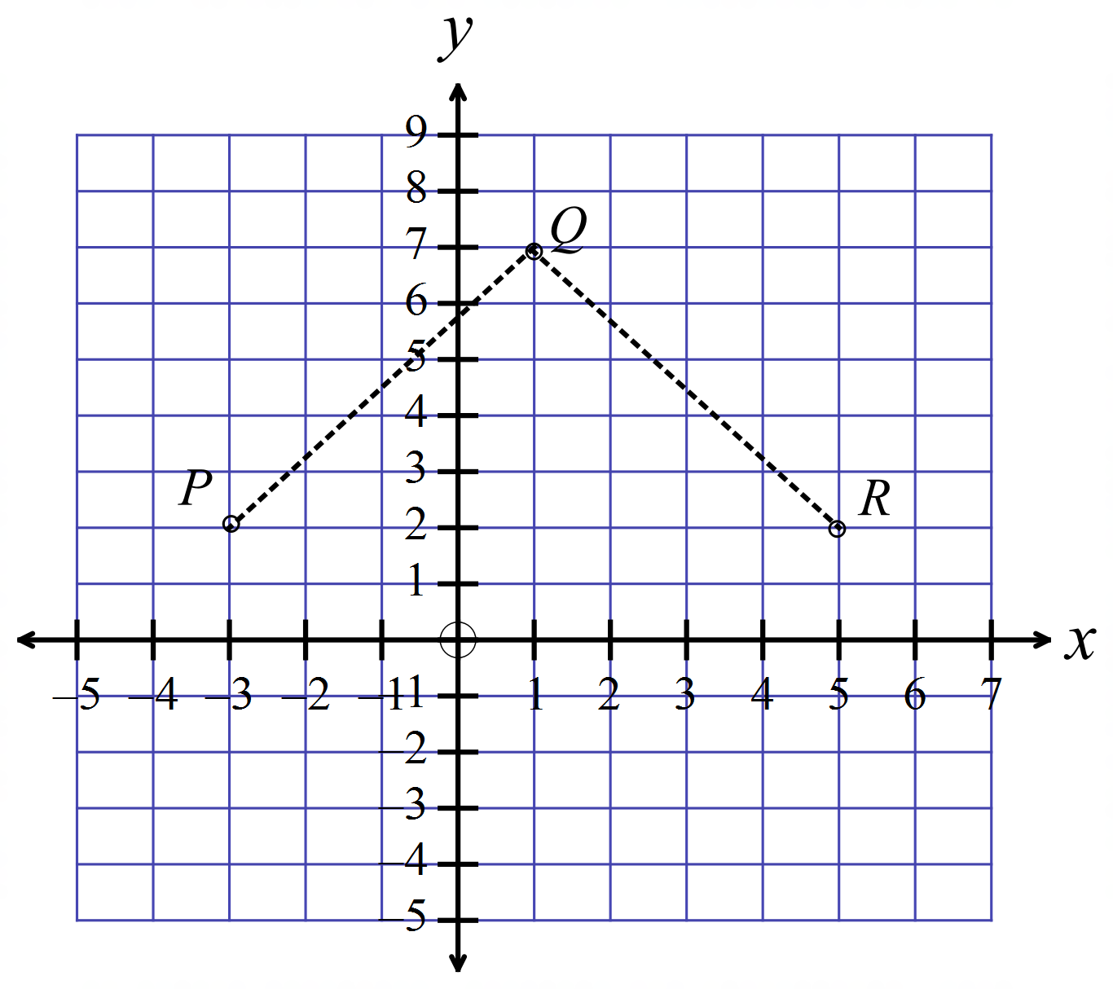The points P, Q and R are three vertices of a rhombus.
The point S is the fourth vertex.

What are the coordinates of the point S?

.....................................................................

.....................................................................

.....................................................................

What is the midpoint of the interval joining 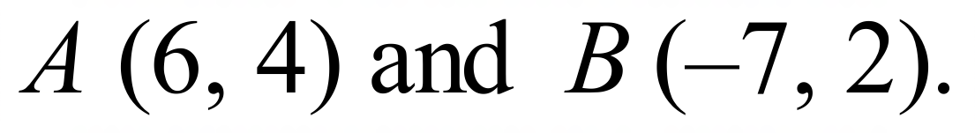

……………………………………………………………………………………………….

……………………………………………………………………………………………….
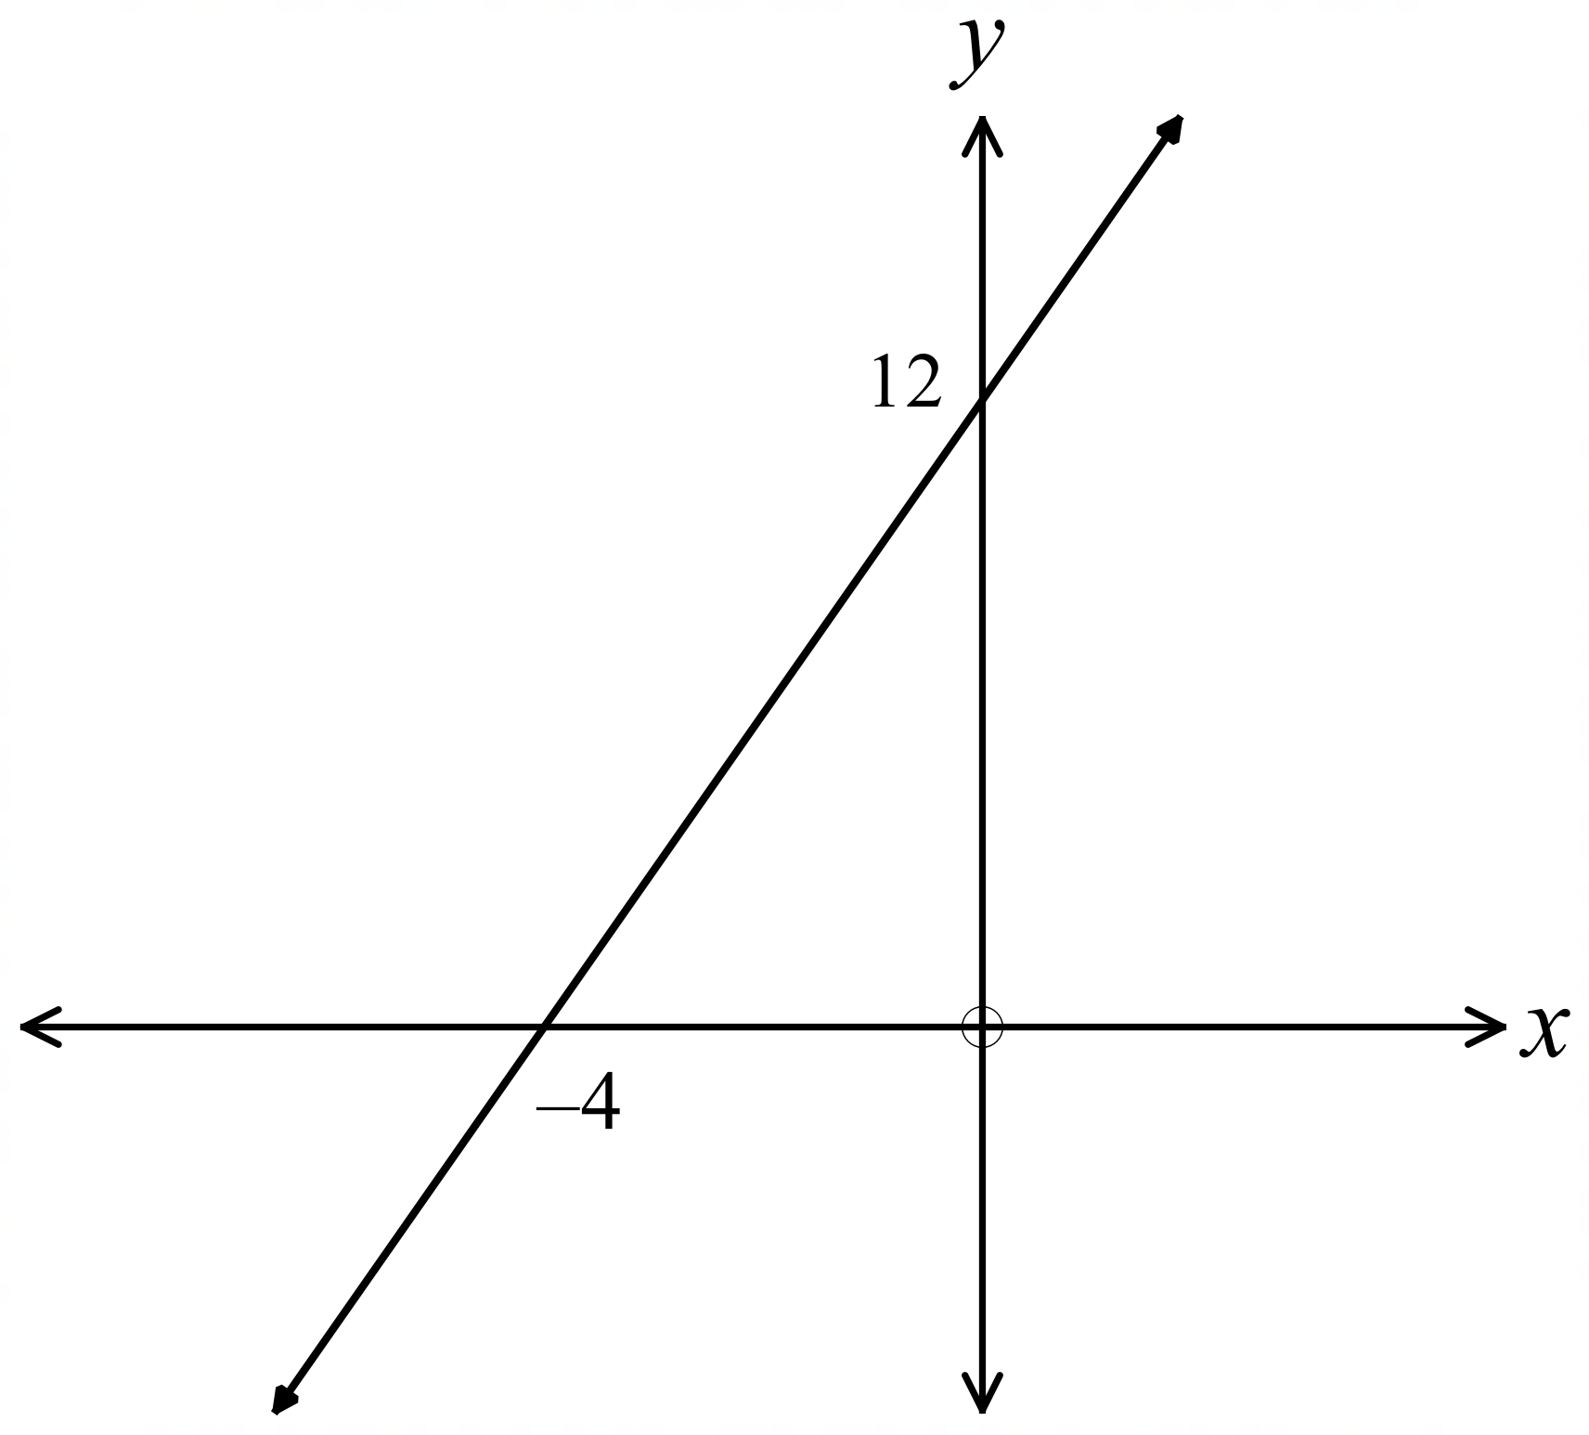What is the gradient of the line shown?

…………………………………………

………………………………………….

…………………………………………

………………………………………….

What is the length of the interval joining 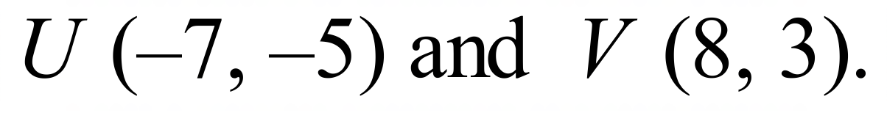

……………………………………………………………………………………………….

……………………………………………………………………………………………….
What is the gradient of the line joining 

……………………………………………………………………………………………….

……………………………………………………………………………………………….
What is the value of p ?

……………………………………………………………………………………………….

……………………………………………………………………………………………….
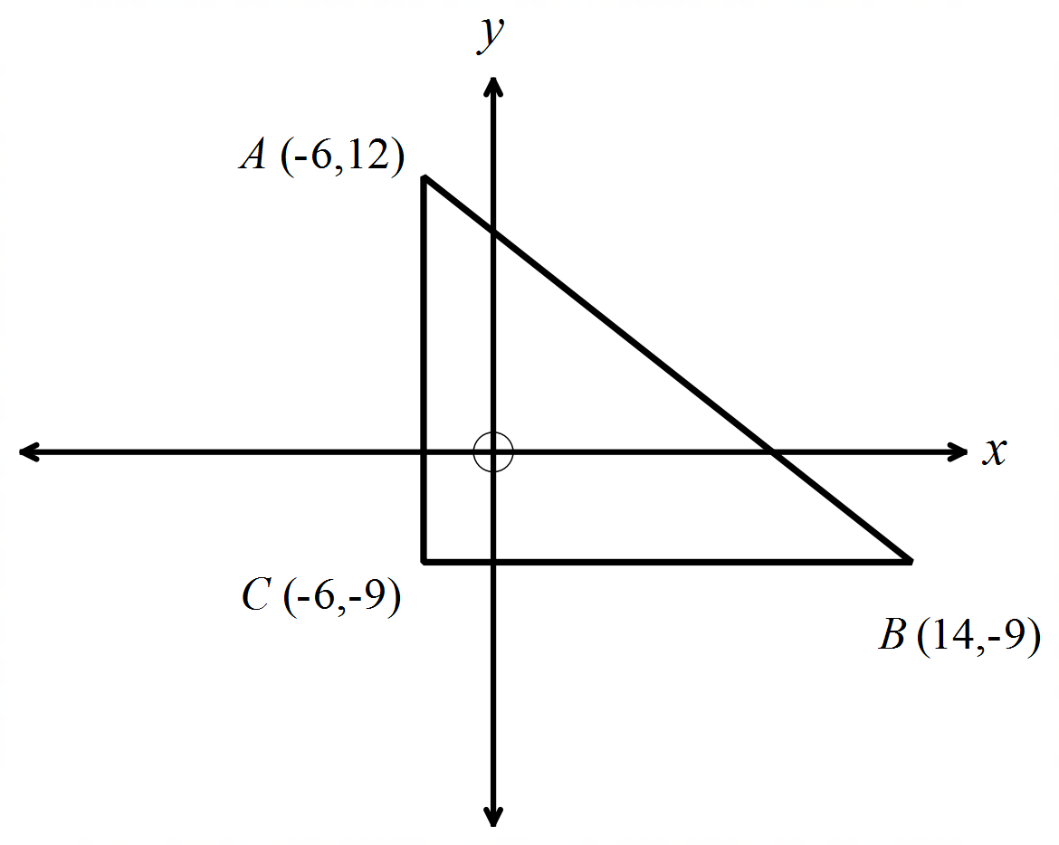ABC is a right triangle on the number plane.
Find the perimeter of the triangle.

……………………………………………

……………………………………………

……………………………………………

……………………………………………
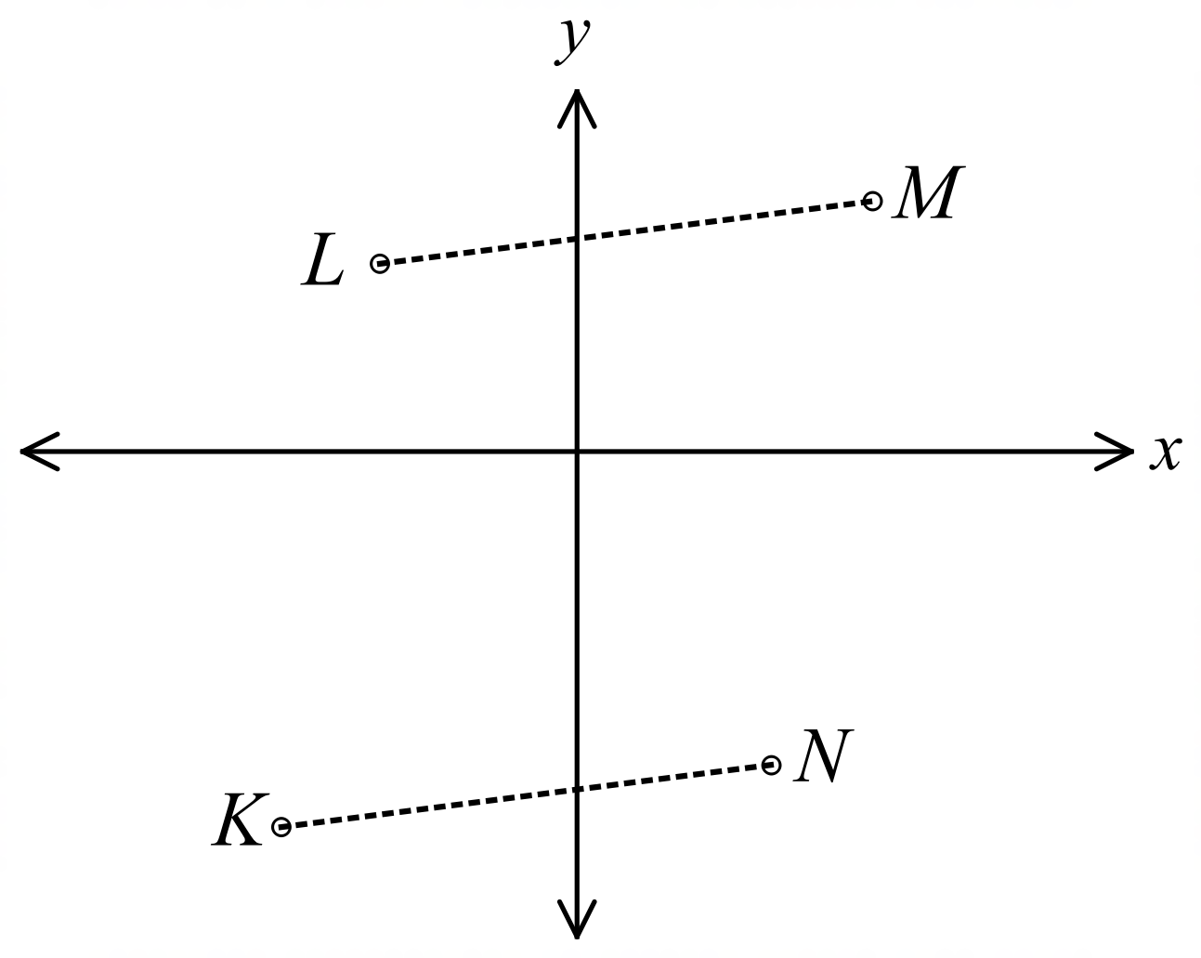Questions 13 – 15 refer to the diagram below.

The points K (–6, –6), L (–4, 3), M (6, 5) and
N (4, –4) are shown on the number plane.
The line segments LM and KN are joined.

Show that the segment LM is parallel to KN.

………………………………………………………………………………………….

………………………………………………………………………………………….

………………………………………………………………………………………….
The segments LN and KM are joined.
Show that, the segment LN bisects KM.

………………………………………………………………………………………….

………………………………………………………………………………………….
The segments LK and MN are joined.
Show that, the segments LK and MN are equal in length.

………………………………………………………………………………………….

………………………………………………………………………………………….

School Name
Mathematics Test 2017
Year 9 |  | Coordinate Geometry | Calculator Allowed
 |  | Coordinate Geometry | Name_________________
Section 2 Multiple Choice Section
Mark all your answers on the accompanying multiple choice answer sheet, not on this test paper. You may do any working out on this test paper. Calculators are allowed for this section.

Questions 1 and 2 refer to the number plane below.
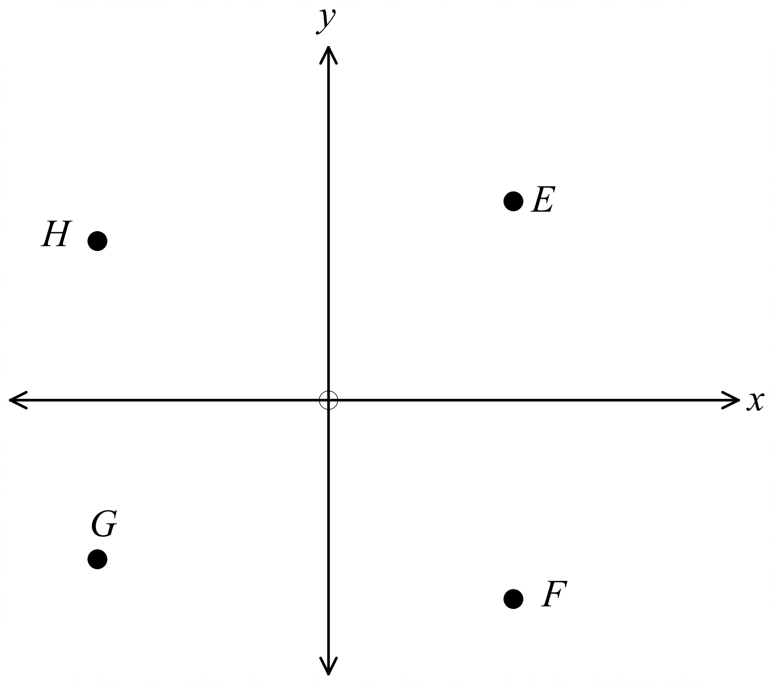

Which of the points lies in the 4th quadrant of the number plane?

A. Point E B. Point F C. Point G D. Point H
The gradient of the interval joining two of the points has a gradient of –1.
Which two points were joined?

A. Points E and F B. Points E and G
C. Points E and H D. Points F and H
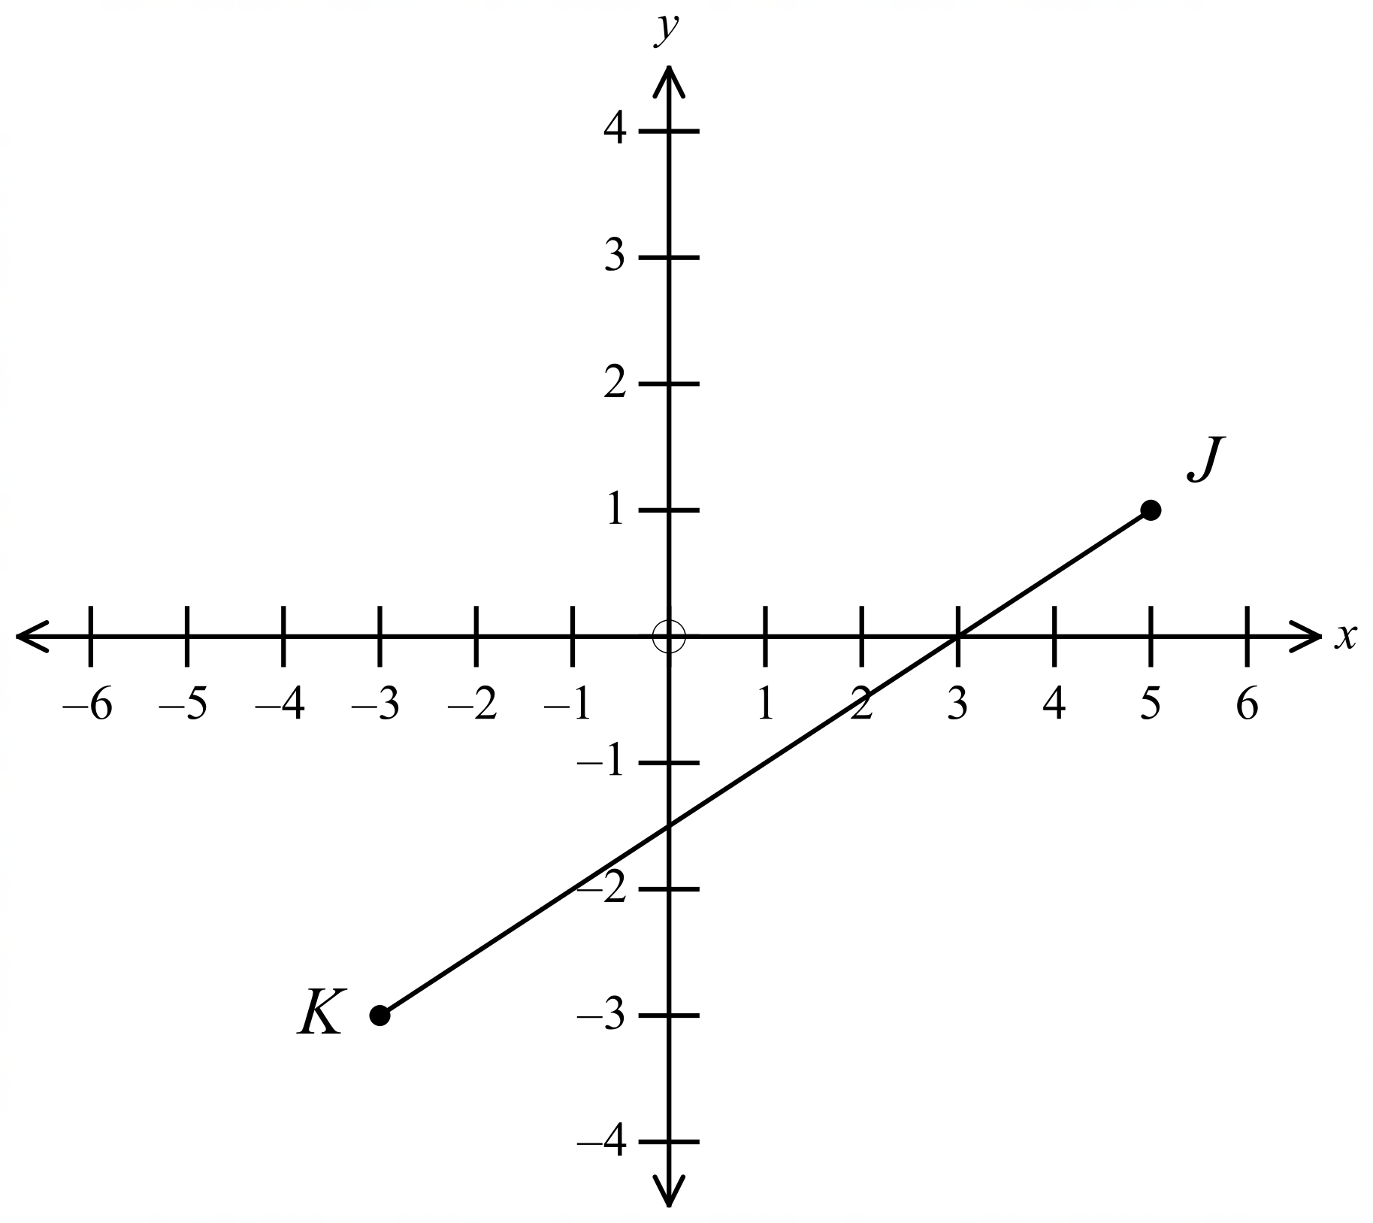What is the gradient of the line JK?

A. 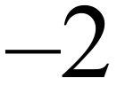 B. 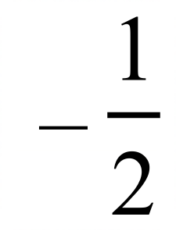 C.  D. 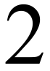

What is the midpoint of the interval joining (6, –1) and (–4, 7)?

A. (1, 3) B. (1, –3) C. (–1, 3) D. (5, 4)
What is the distance between the points C(–2 , –7) and D(6, 8)?
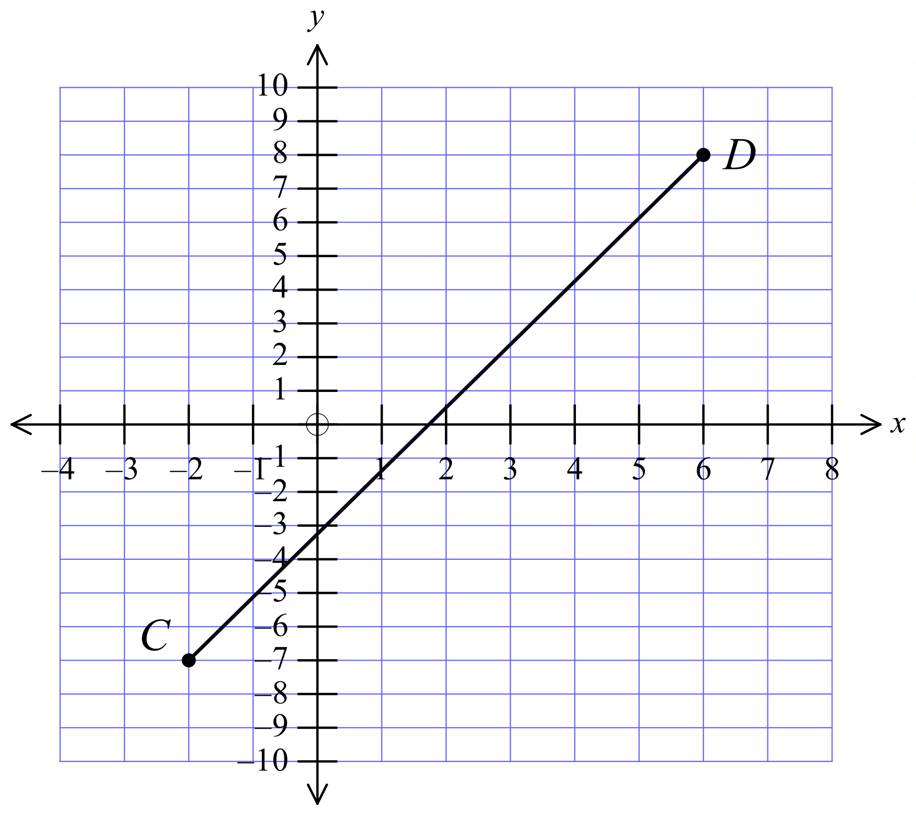

A. 8 units B. 12 units C. 15 units D. 17 units
Questions 6 – 8 refer to the number plane shown.
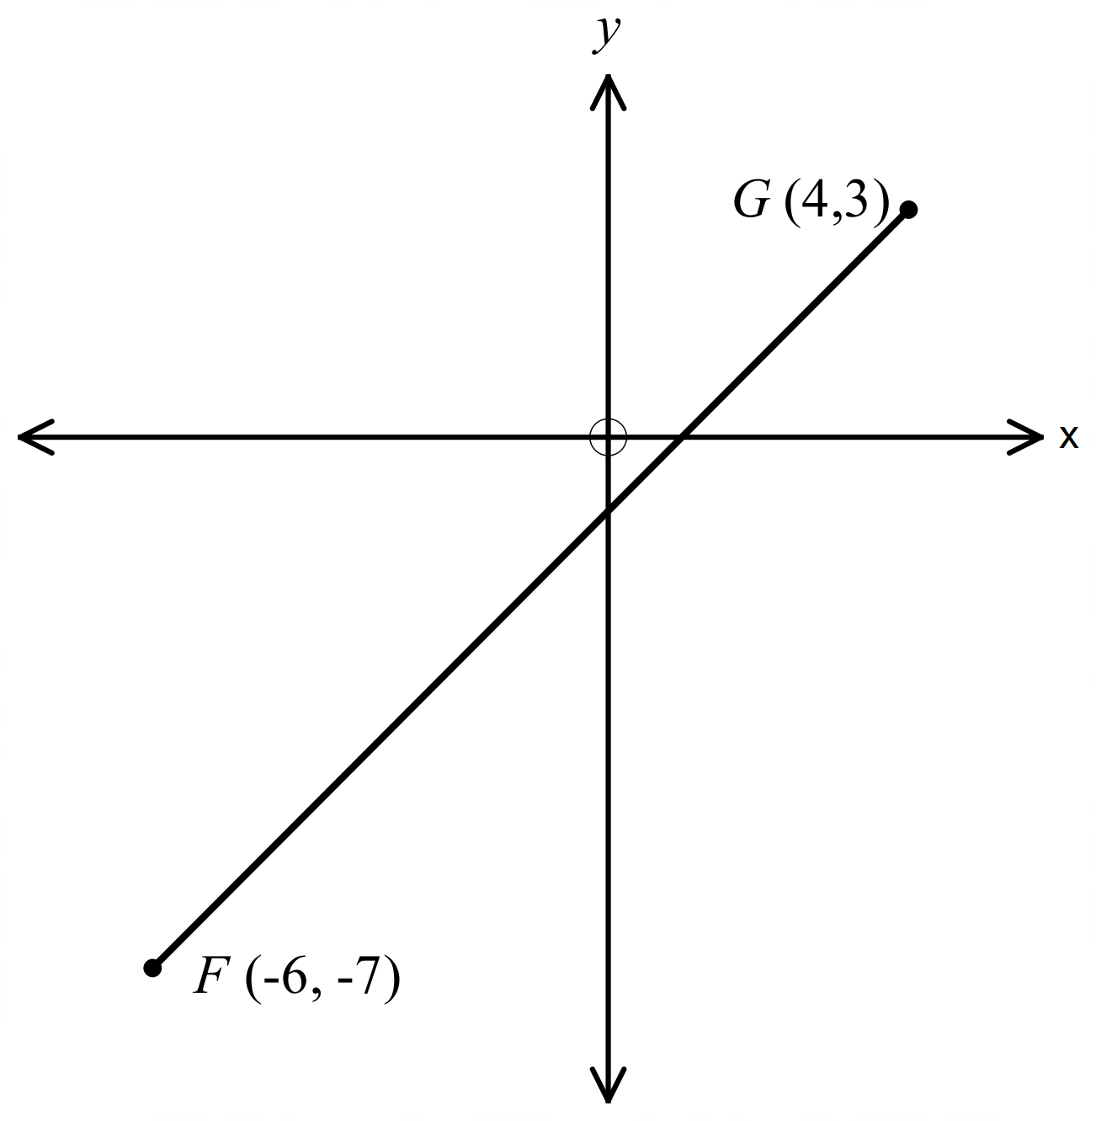

Find the midpoint of the interval FG.

A. 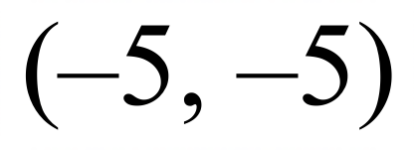 B. 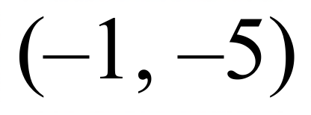 C. 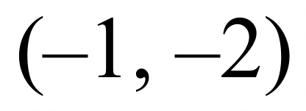 D. 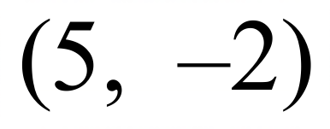
What is the gradient of the interval FG?

A. –1 B. 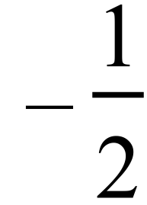 C.  D. 1
What is the length of the interval FG ?

A. 10 units B. 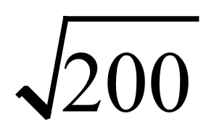 units C. 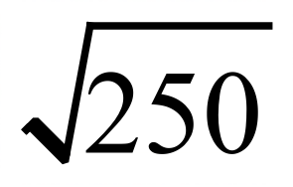 units D. 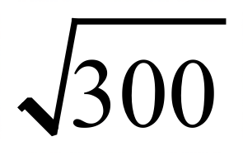 units
Find the gradient of the interval joining T(–6, 4) and U(–9, –2).

A. 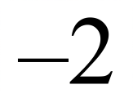 B. 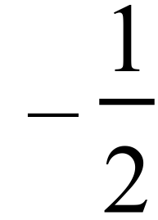 C.  D. 2
Find the length of the interval joining D(–6, 1) and E(–5, 8).

A.  B.  C.  D. 
The points A (9, –4), B (4, 7) and C (–2, 1) are joined to form a triangle.
Which term could correctly describe the triangle?

A. Equilateral B. Isosceles C. Scalene D. Right Angled
The midpoint of the interval PQ is the point M (4, 1).
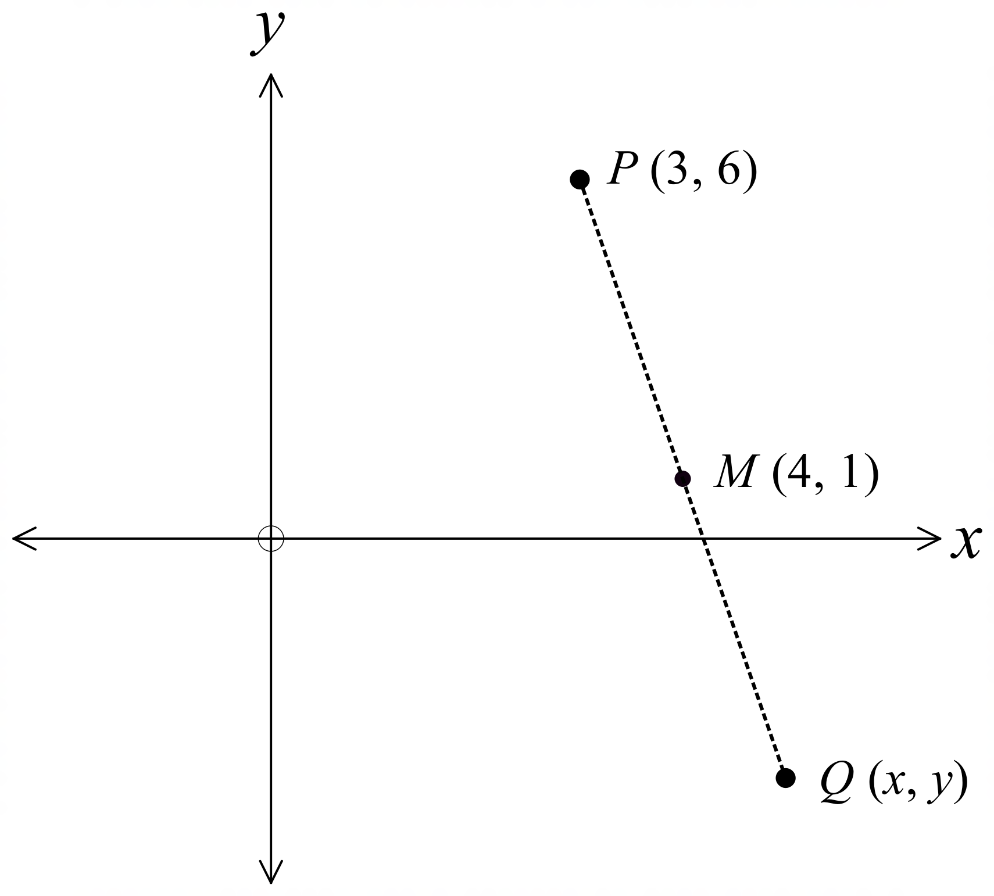P has coordinates (3, 6).
What are the coordinates of B?

A. (–5, –4)

B. (–5, 4)

C. (5, –4)

D. (–4, 5)
Given the points , which statement is true?

A. AB is parallel to CD.
B. AB is parallel to BC.
C. AD is parallel to BC.
D. AD is parallel to CD.

The gradient of the interval PQ is 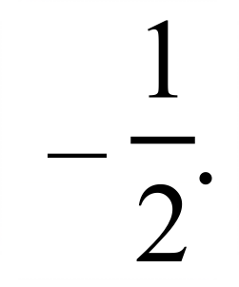
P has coordinates (–4, –6), which of the following could be the coordinates of Q?

A. 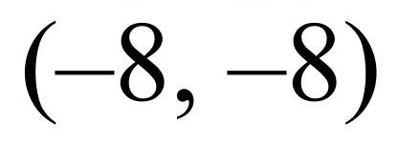 B. 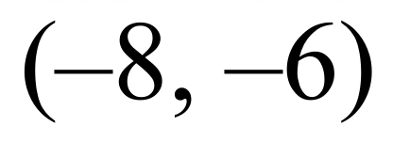 C. 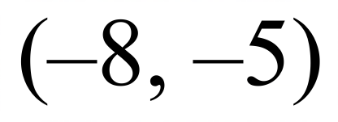 D. 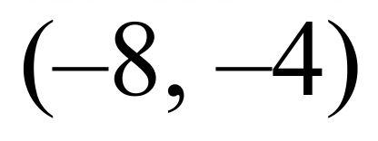
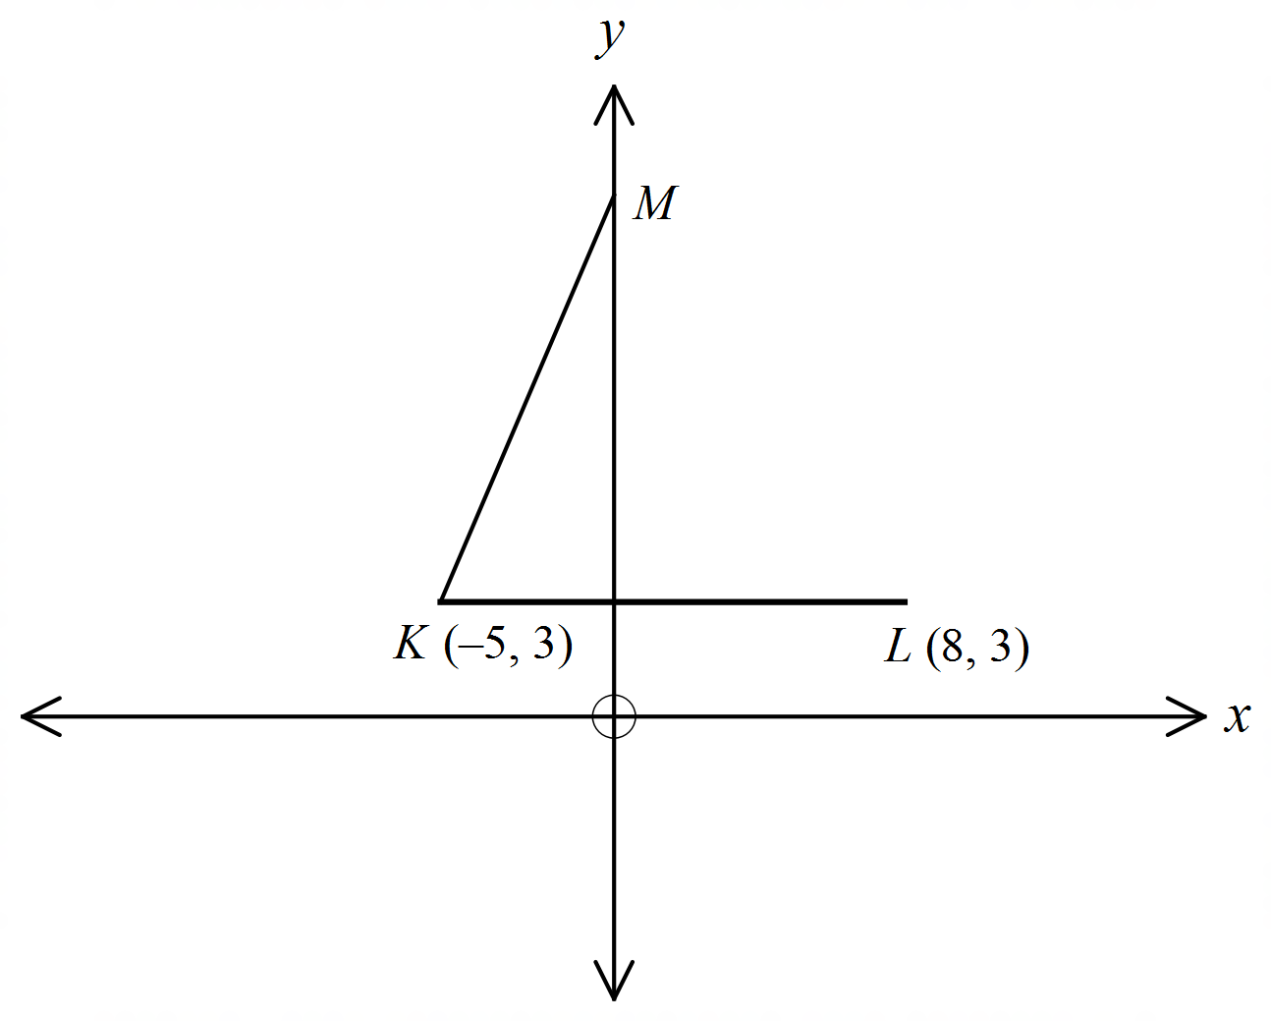The points K (–5, 3) and L (8, 3) are shown.
M is the point on the y axis such that MK = KL.
What are the coordinates on M?

A. (0, 12)
B. (0, 15)
C. (0, 17)
D. (0, 20)

School Name
Mathematics 2017
Multiple Choice Answer Sheet
Coordinate Geometry
Name _____________________________________________
Completely fill the response oval representing the most correct answer.
1. A B C D
2. A B C D
3. A B C D
4. A B C D
5. A B C D
6. A B C D
7. A B C D
8. A B C D
9. A B C D
10. A B C D
11. A B C D
12. A B C D
13. A B C D
14. A B C D
15. A B C D

School Name
Mathematics Test 2017
Year 9 | Coordinate Geometry | Non Calculator Section
ANSWERS

Question | Working and Answer
 | 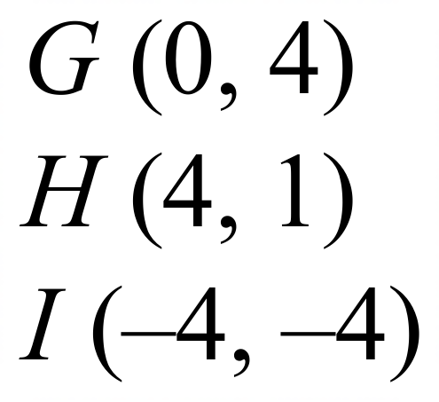
 | 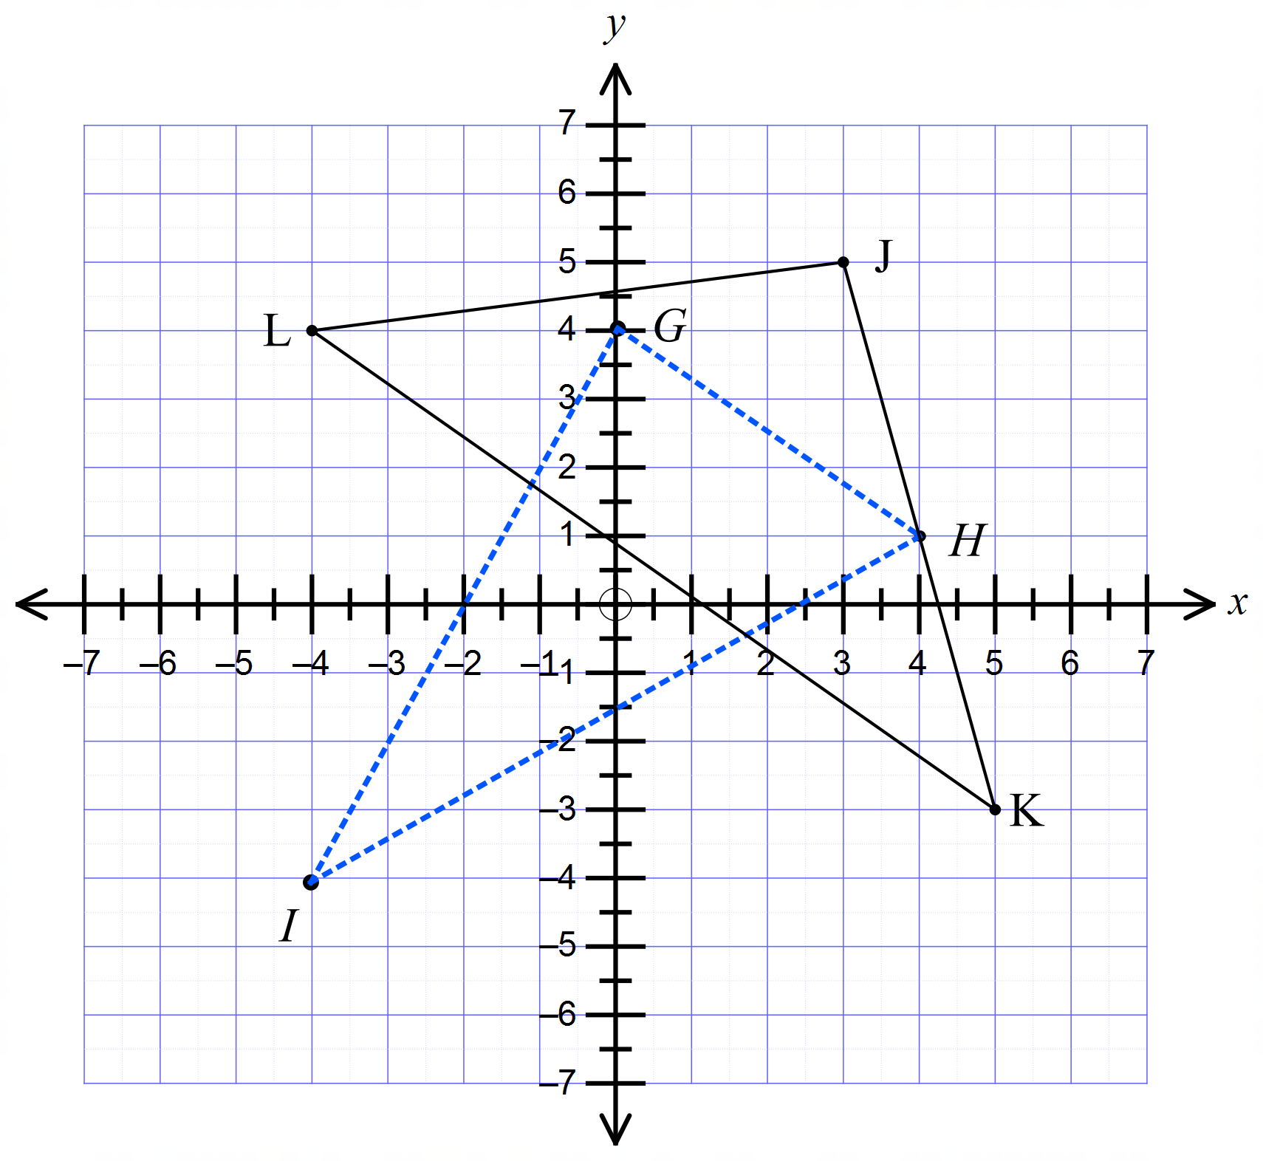
 | 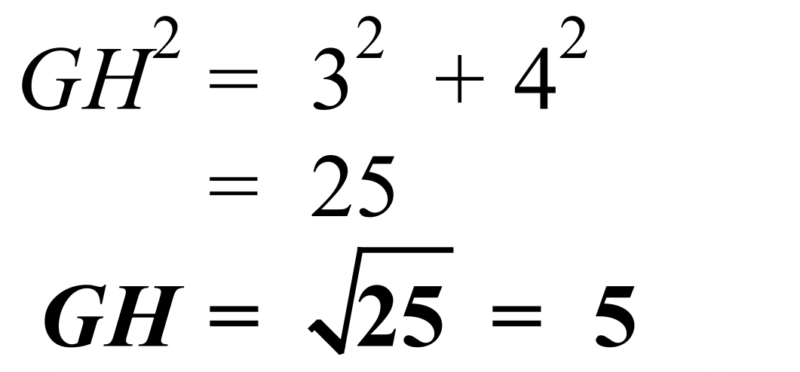
 | 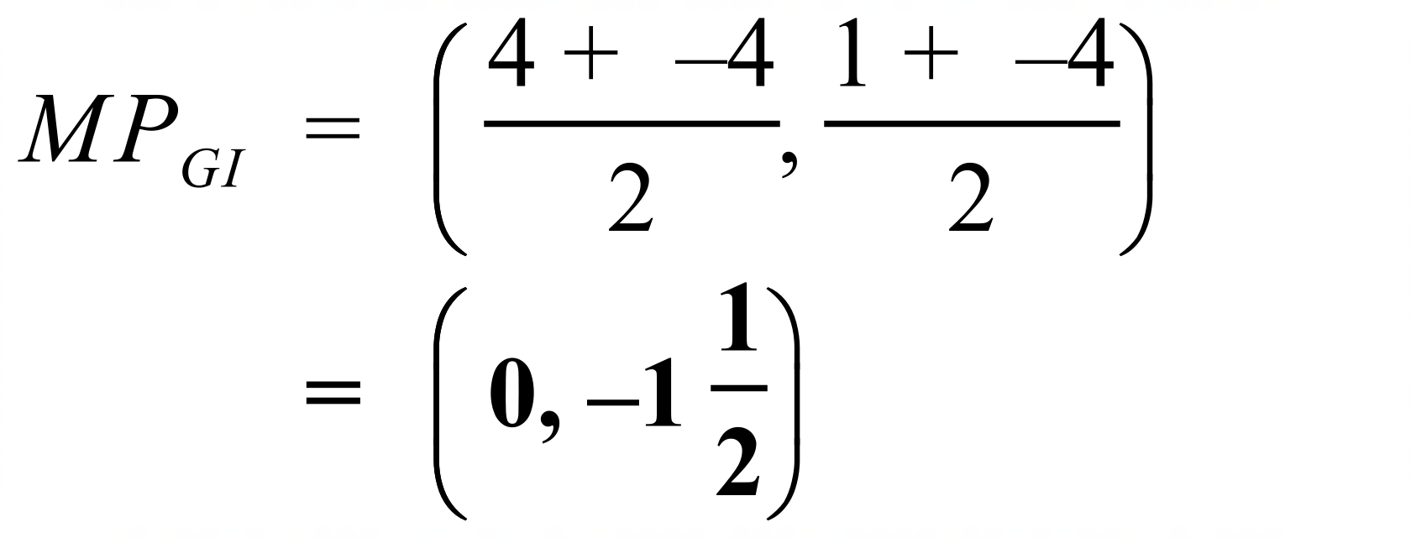
 | 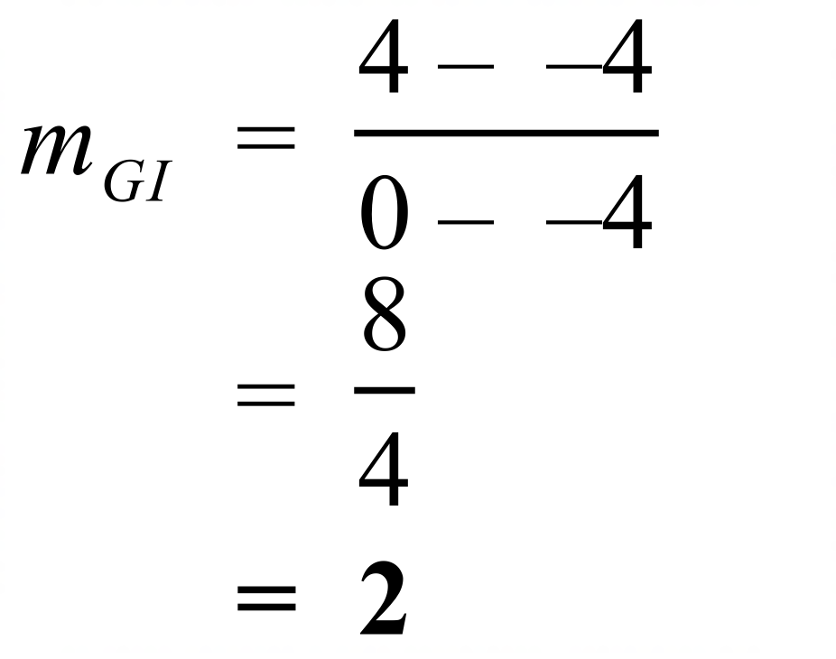
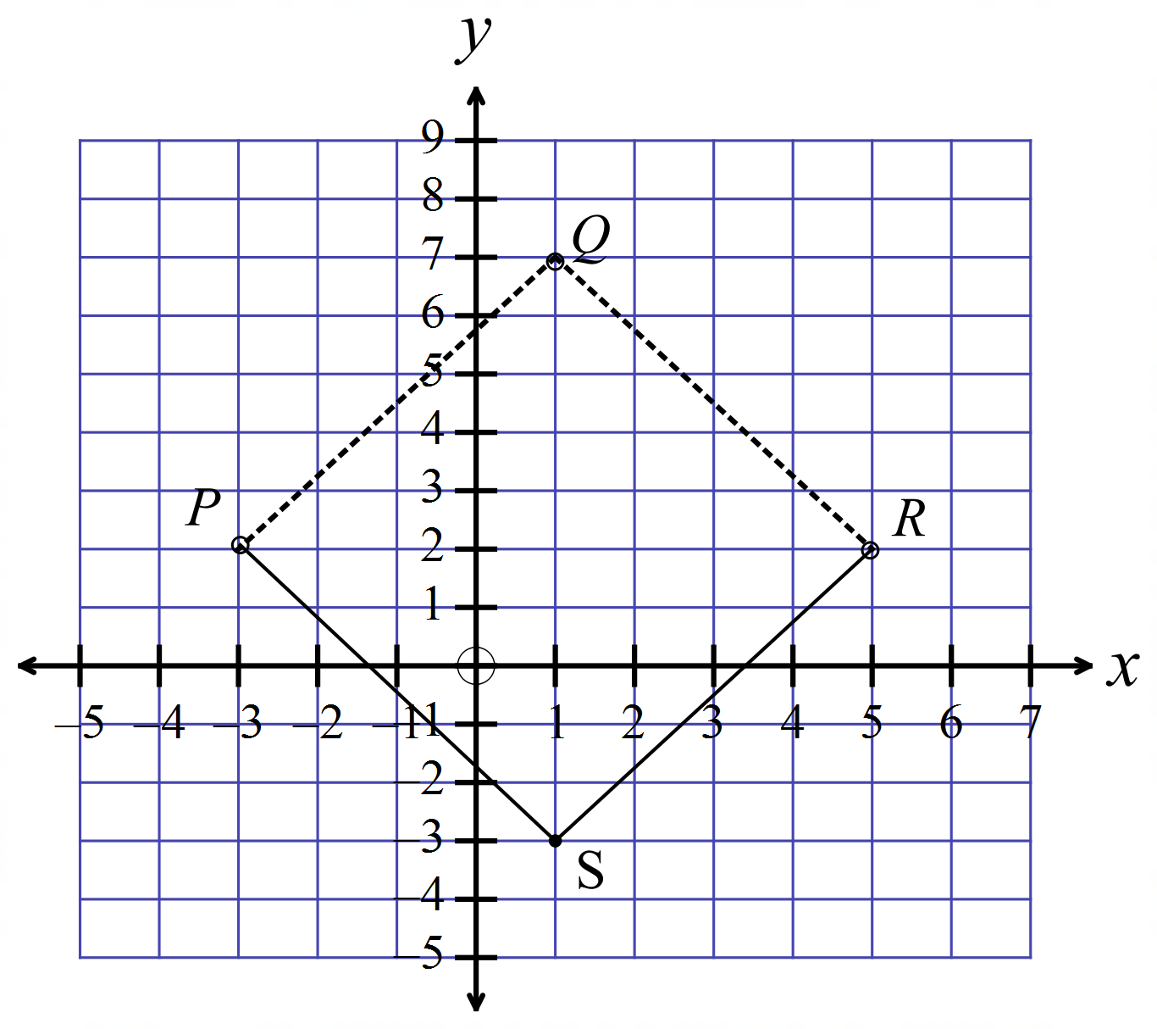

S(1, –3)
Midpoint of
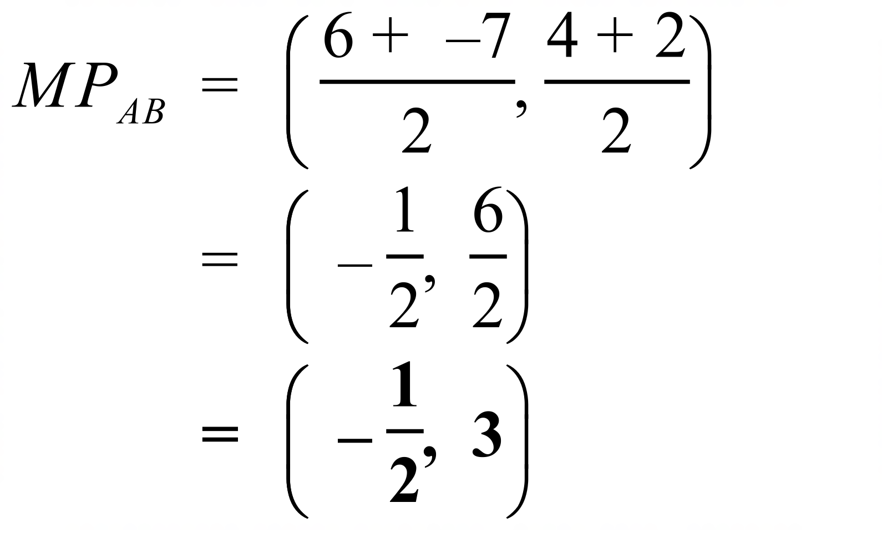
 | 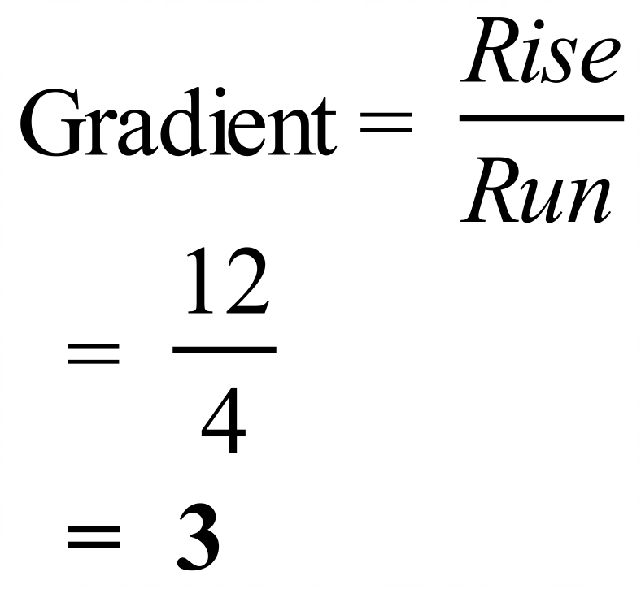
Distance from 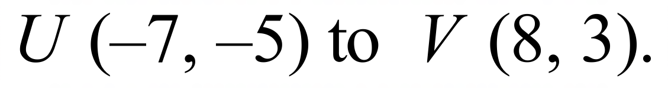
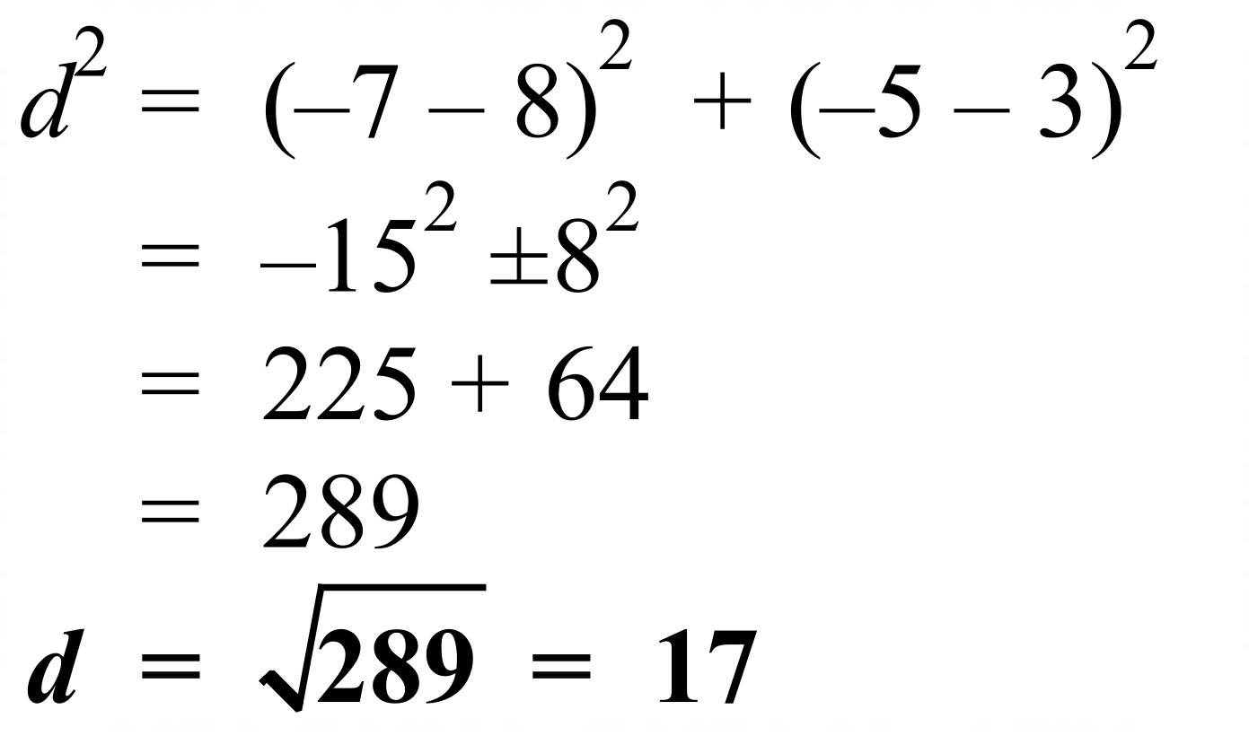
Gradient of the line joining
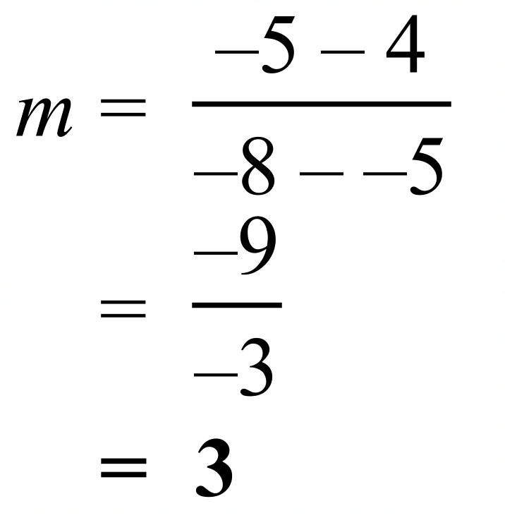
 | 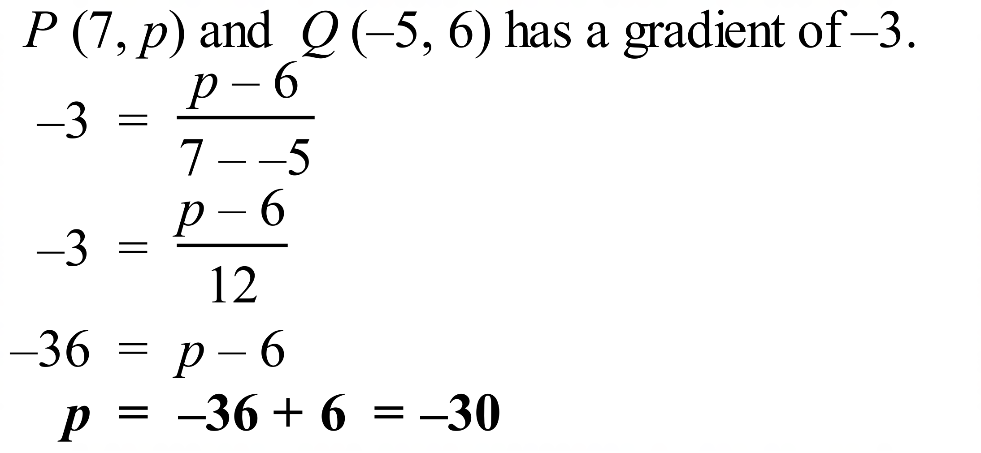
 | 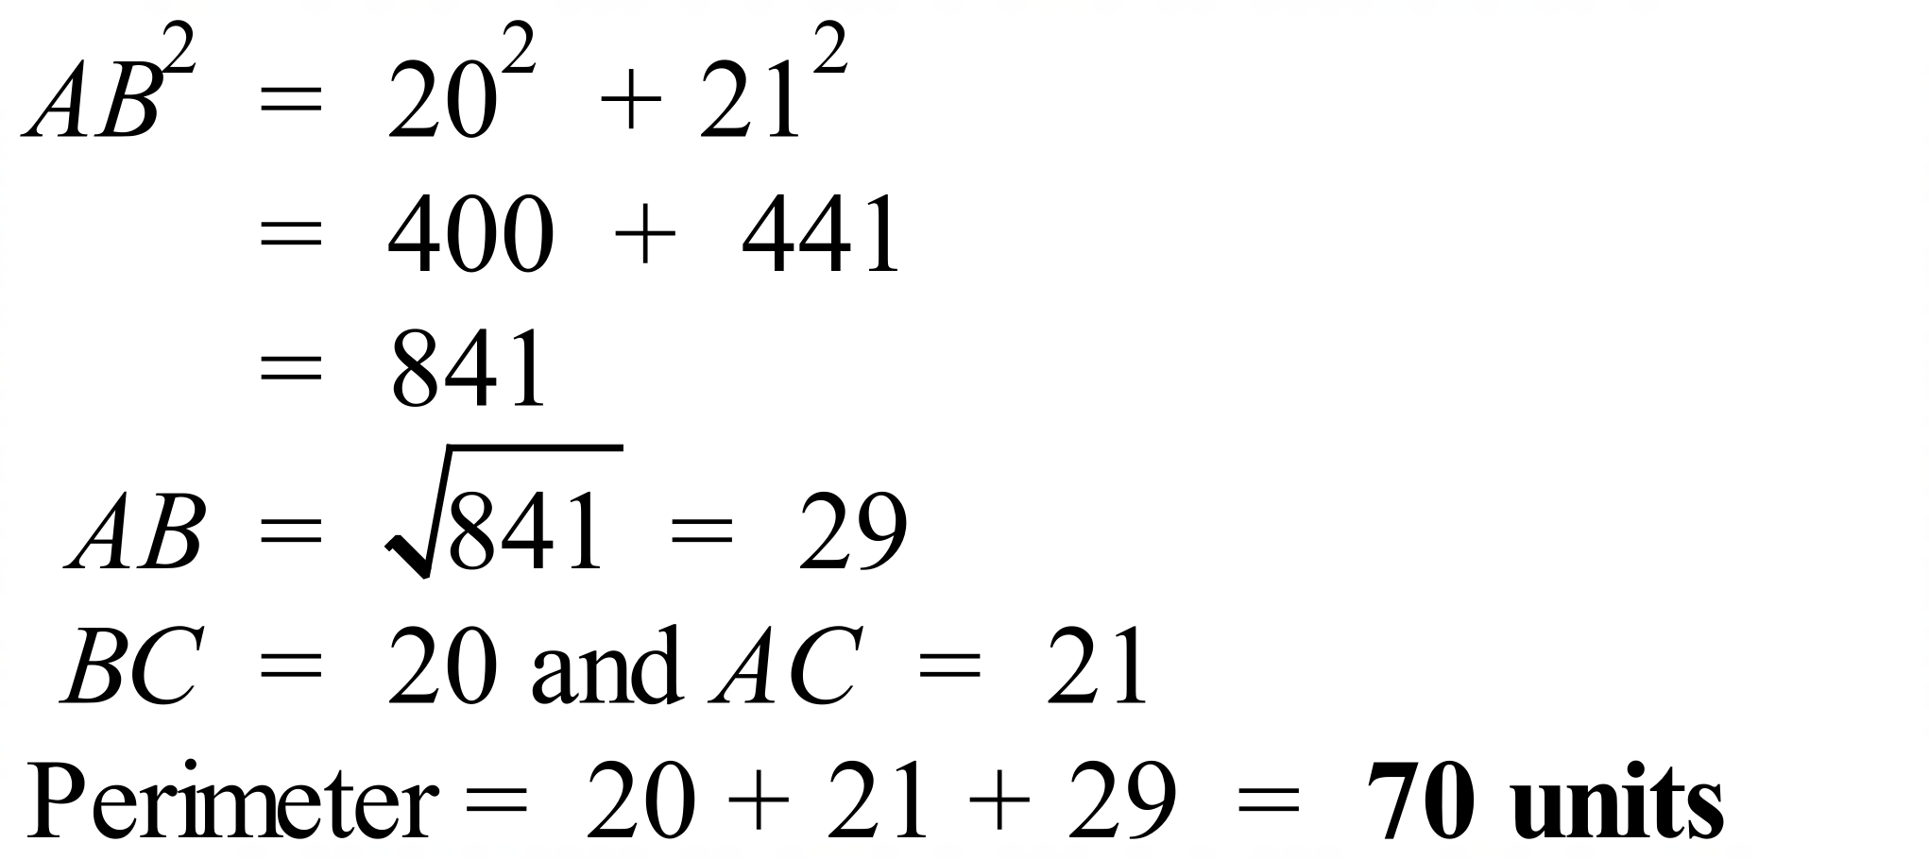
 | 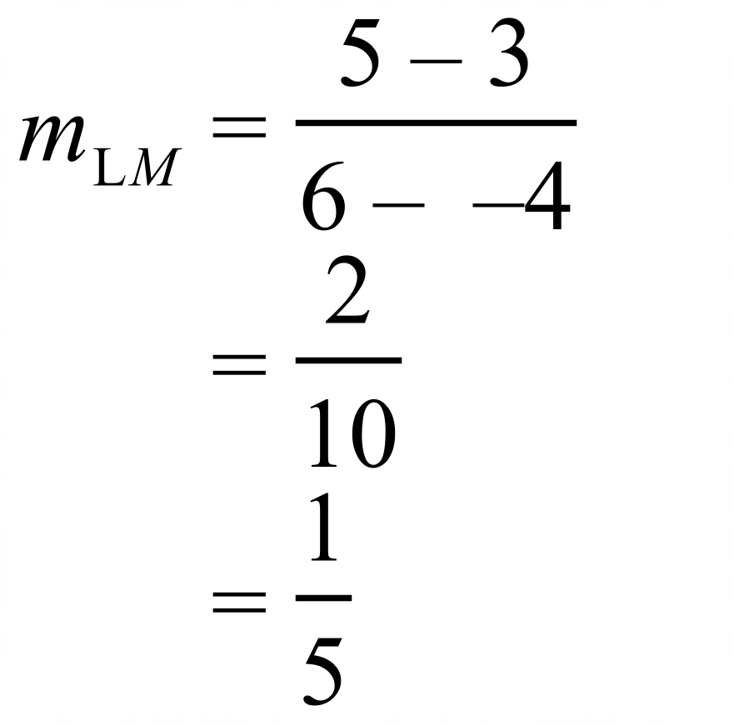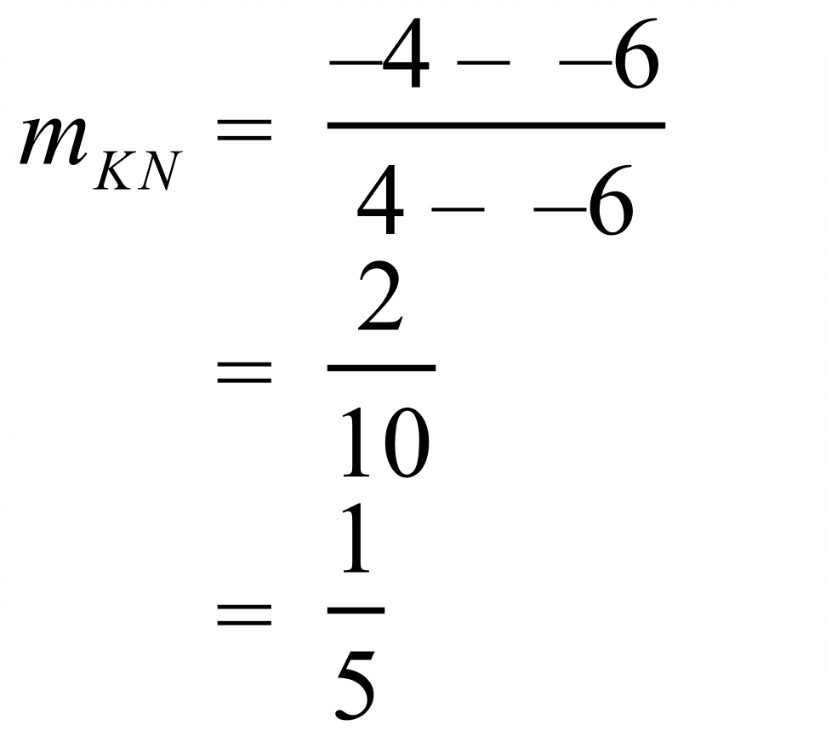
 | 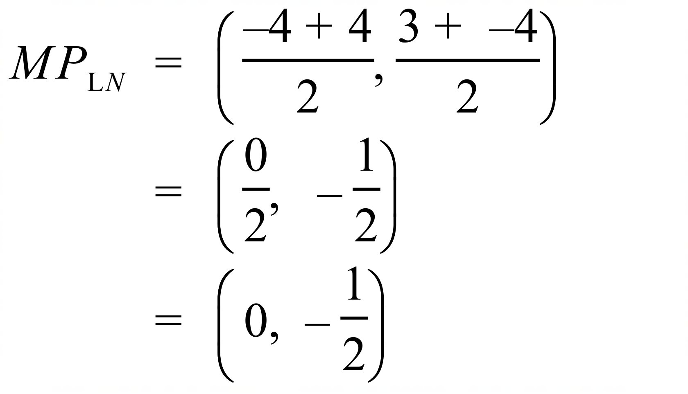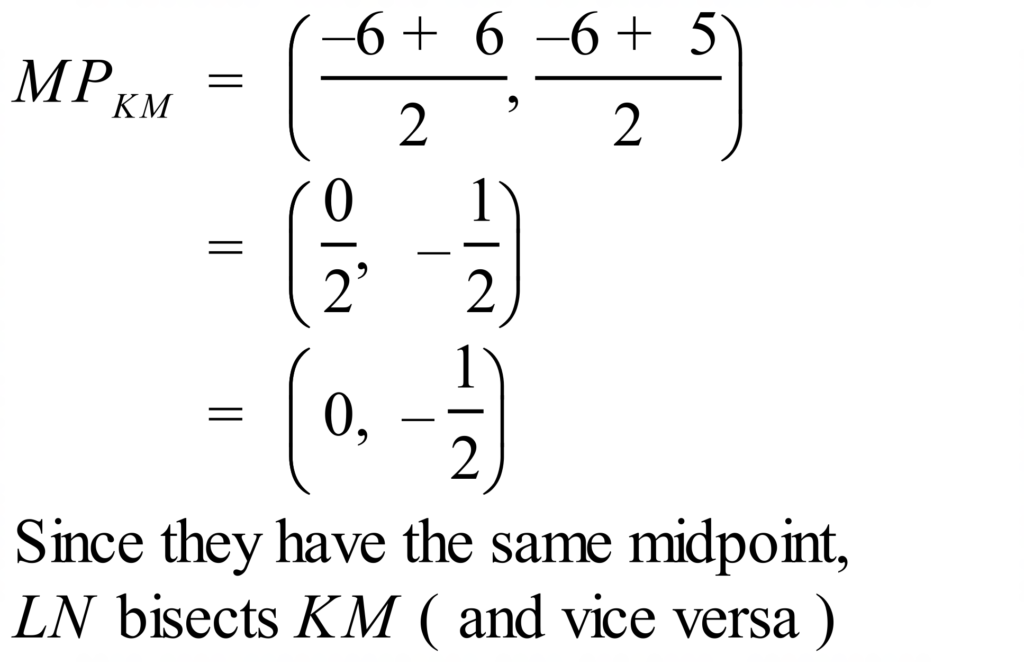
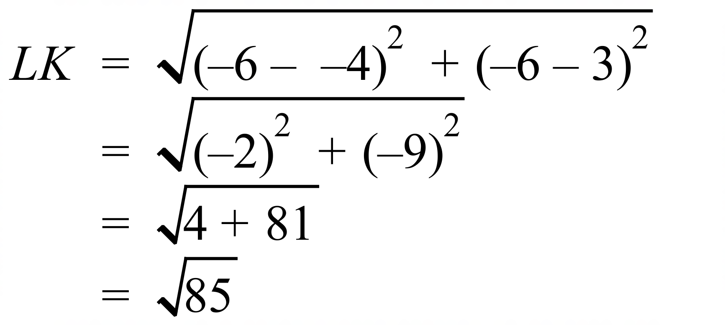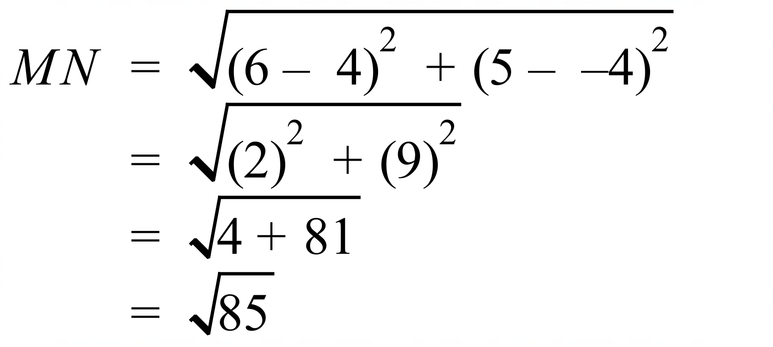
The line segments are equal in length both being .

School Name
Mathematics Test 2017
Year 9 | Coordinate Geometry | Calculator Allowed  Multiple Choice  Section

ANSWERS

Question | Working | M C Answer
 | 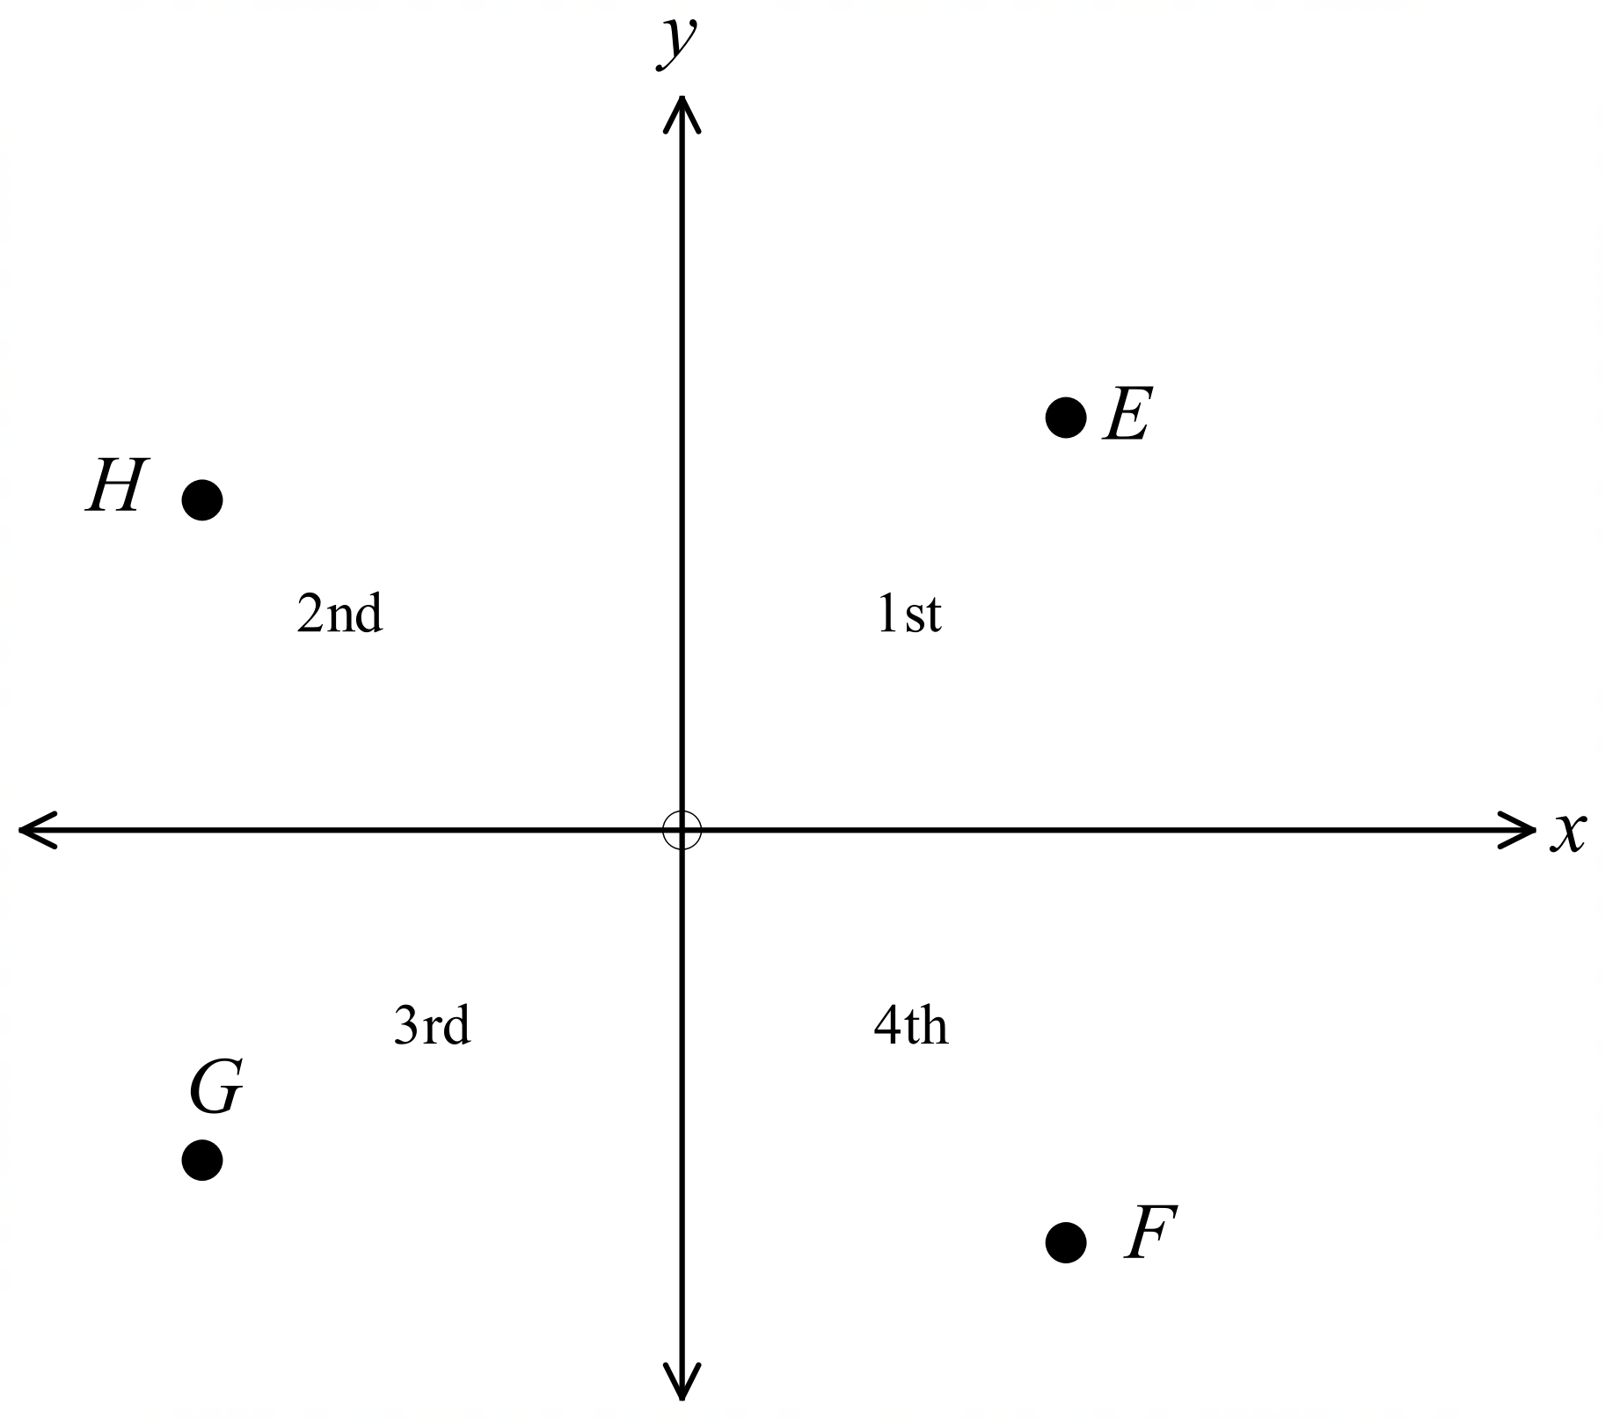  F is in 4th quadrant | B
 | EF is vertical, EG and EH have positive gradients, and only FH could have a gradient of –1 | D
 | 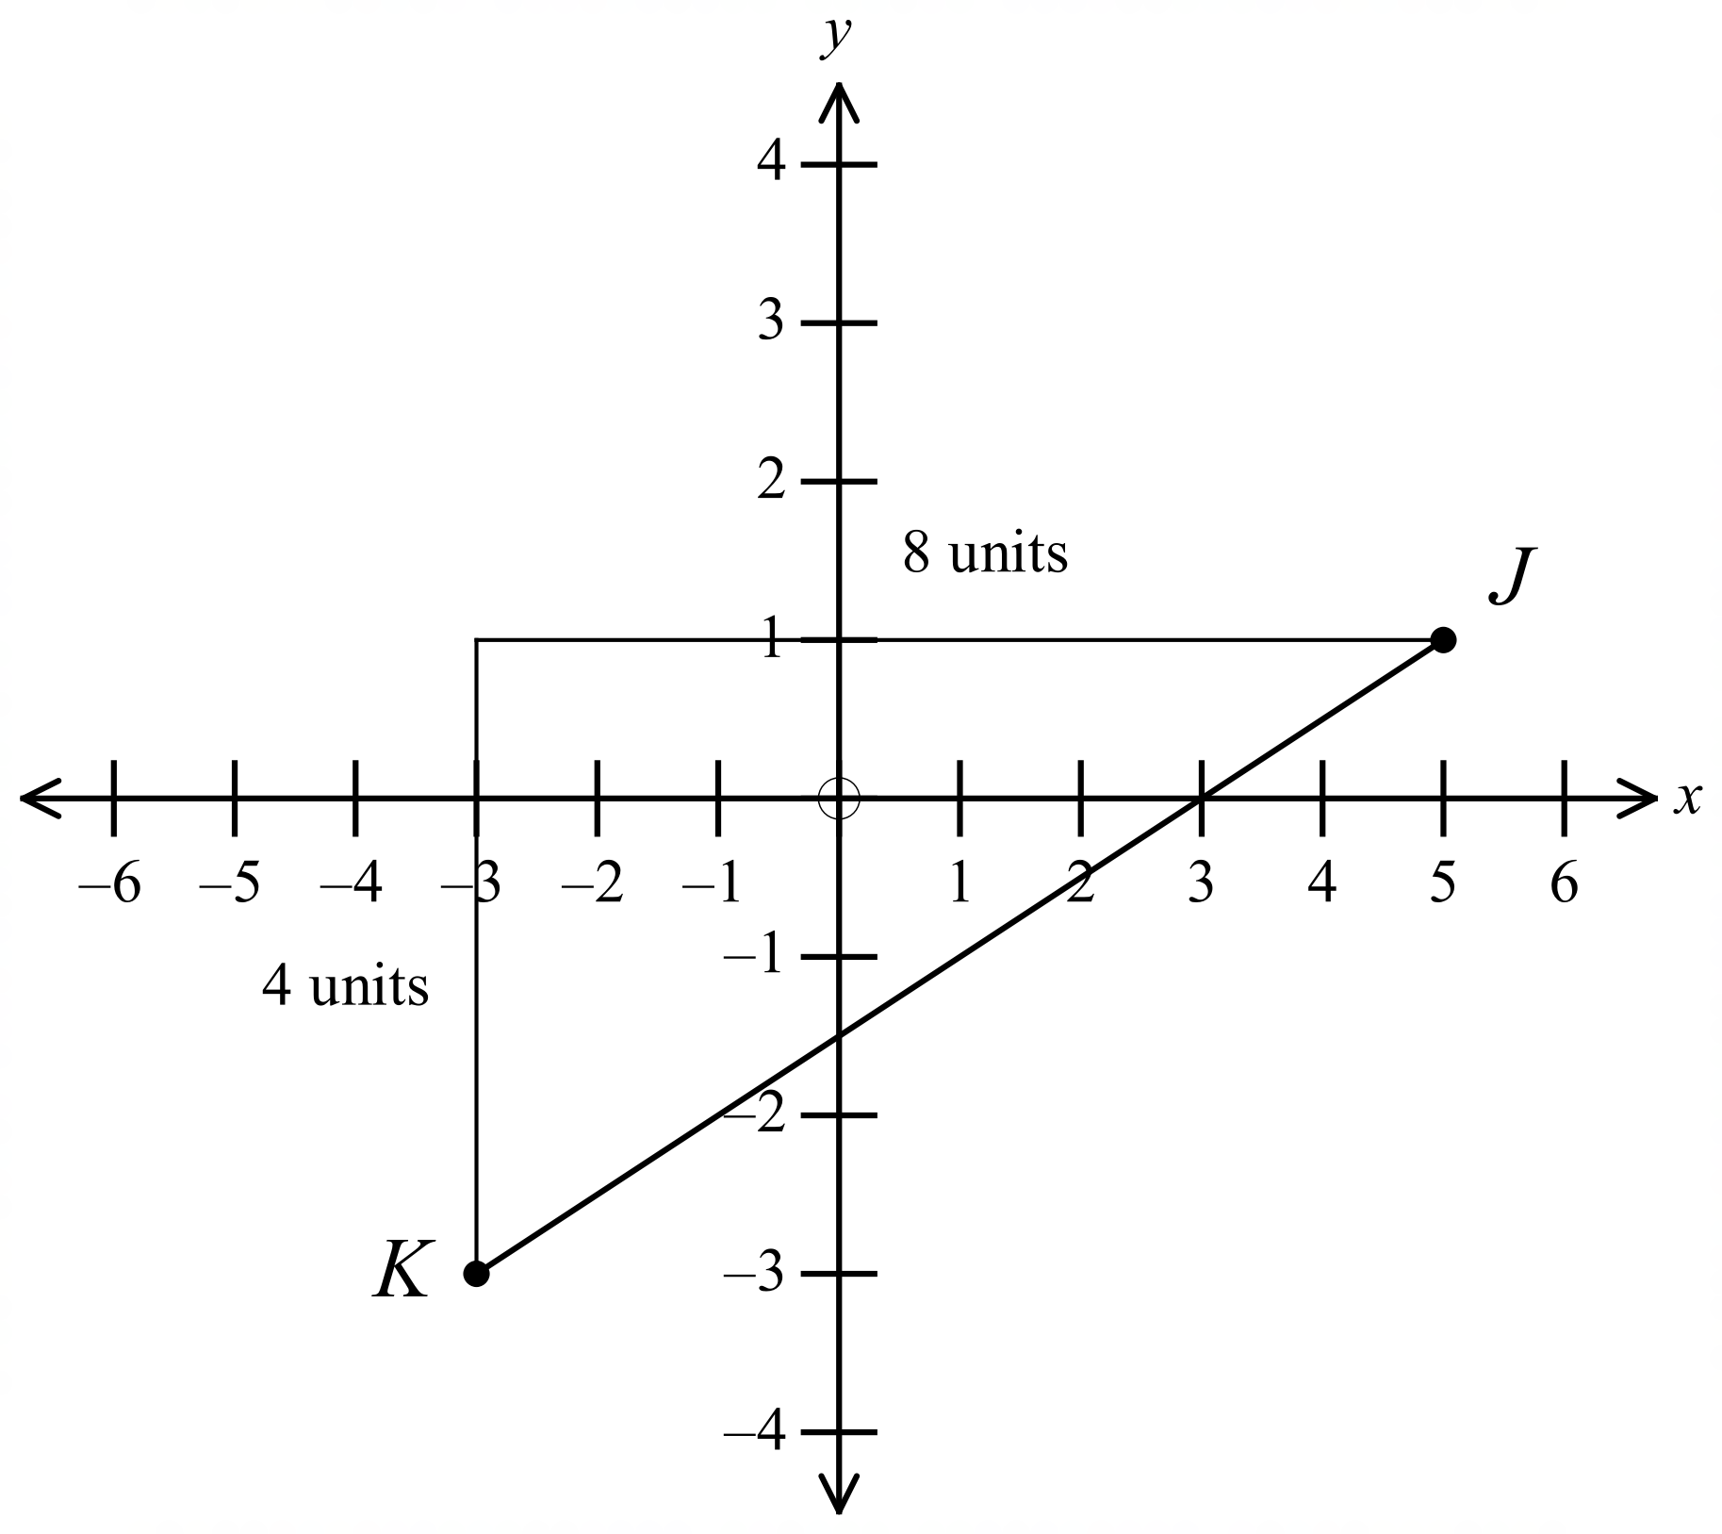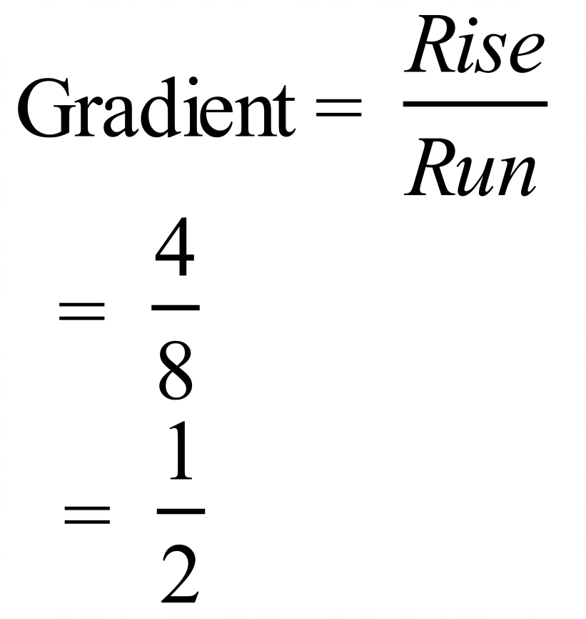 | C
 | Midpoint of (6, –1) and (–4, 7)?  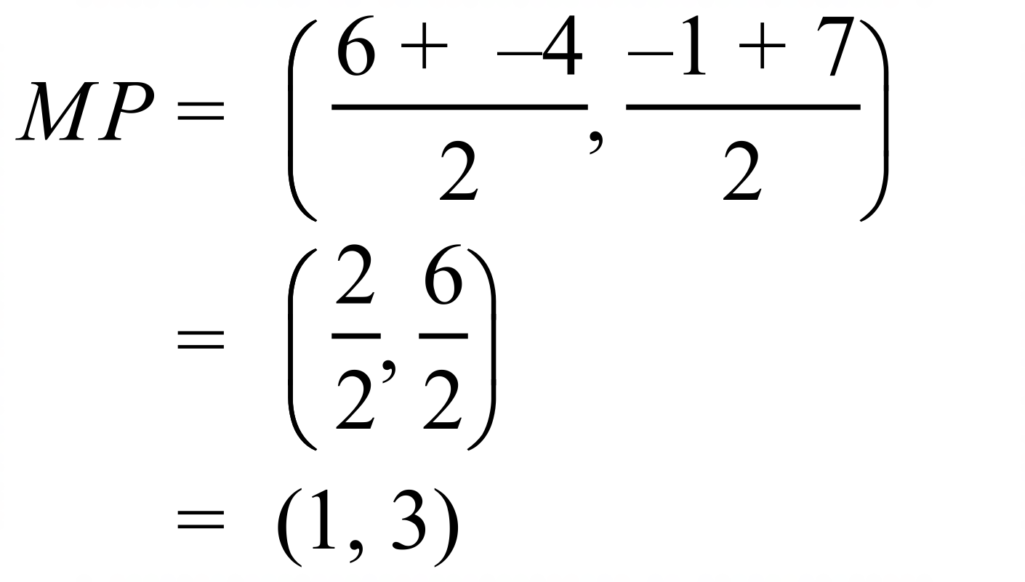 | A
 | 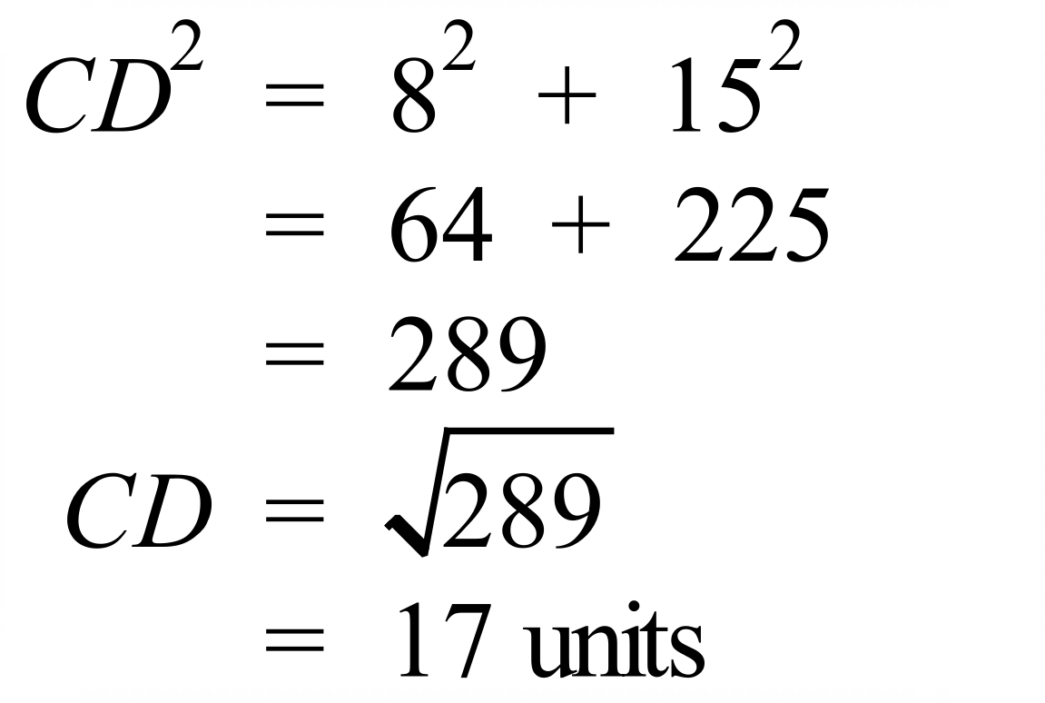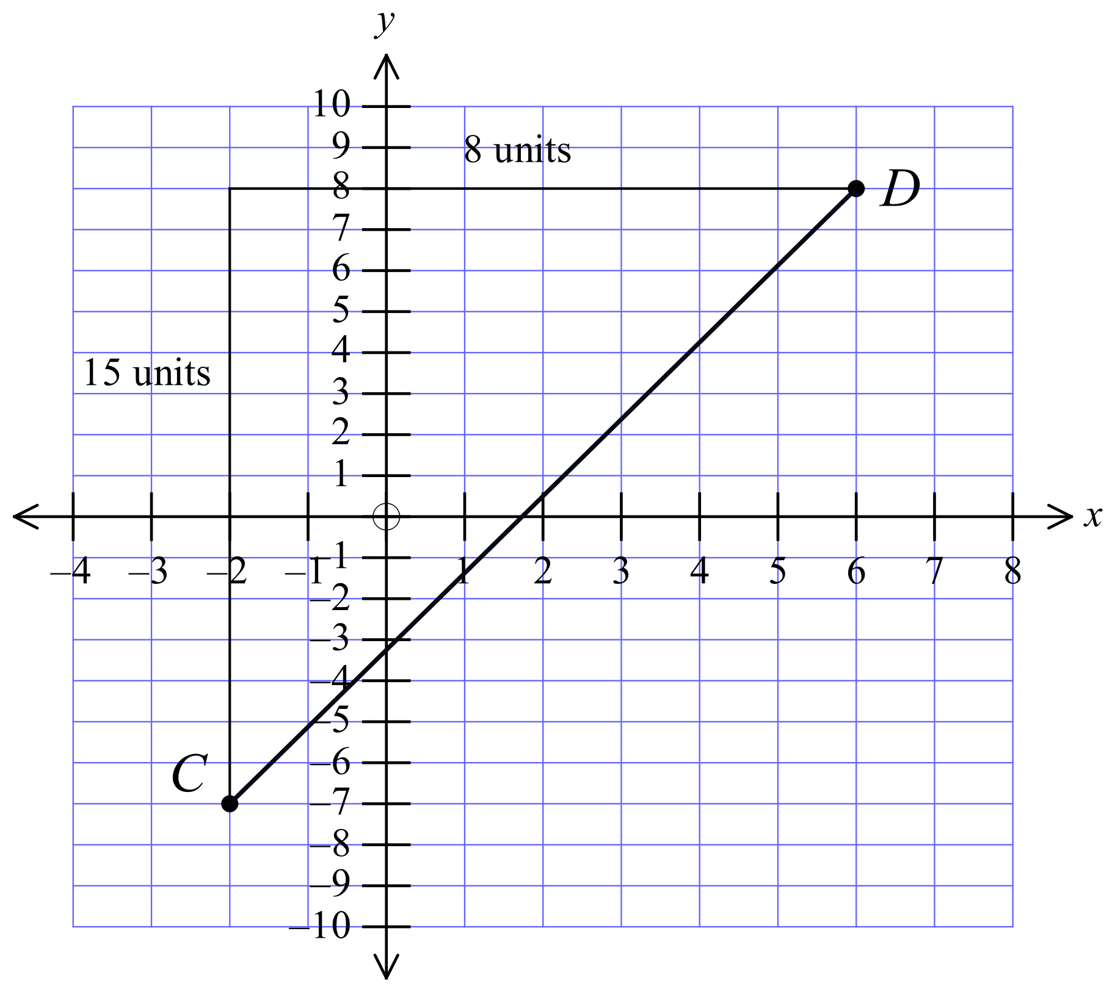 | D
 | 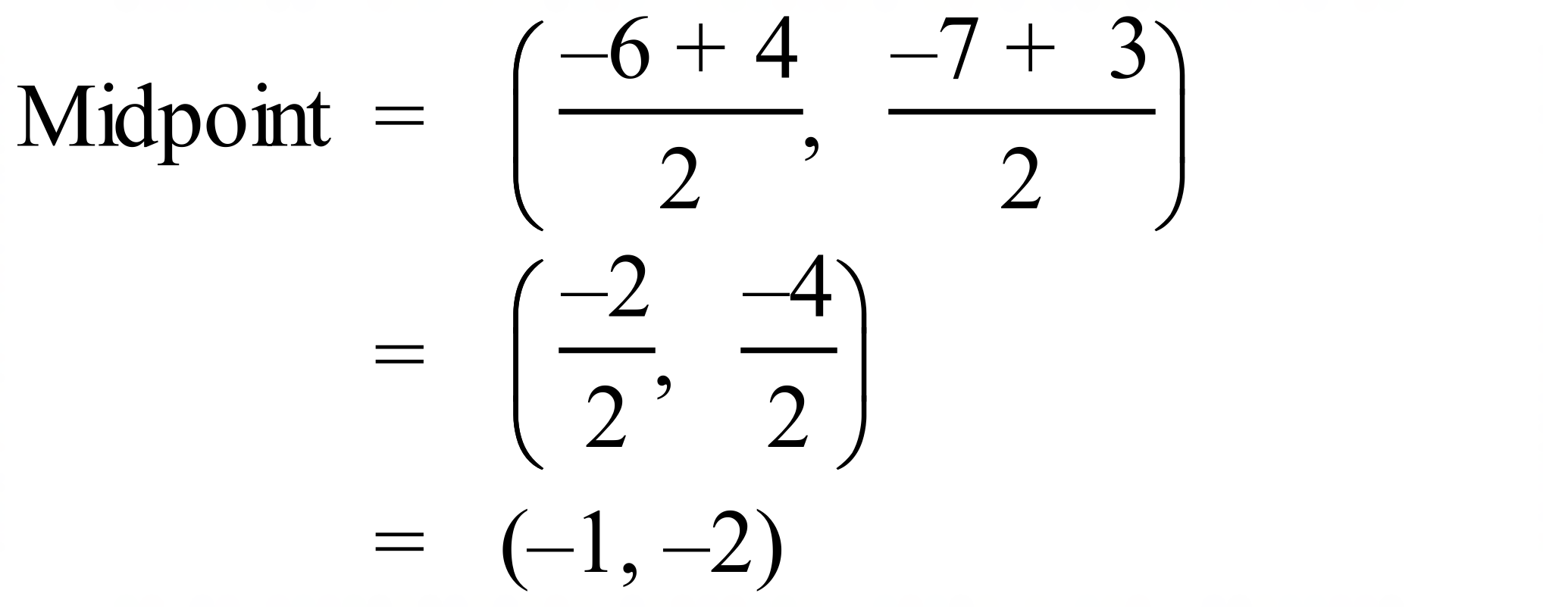 | C
 | 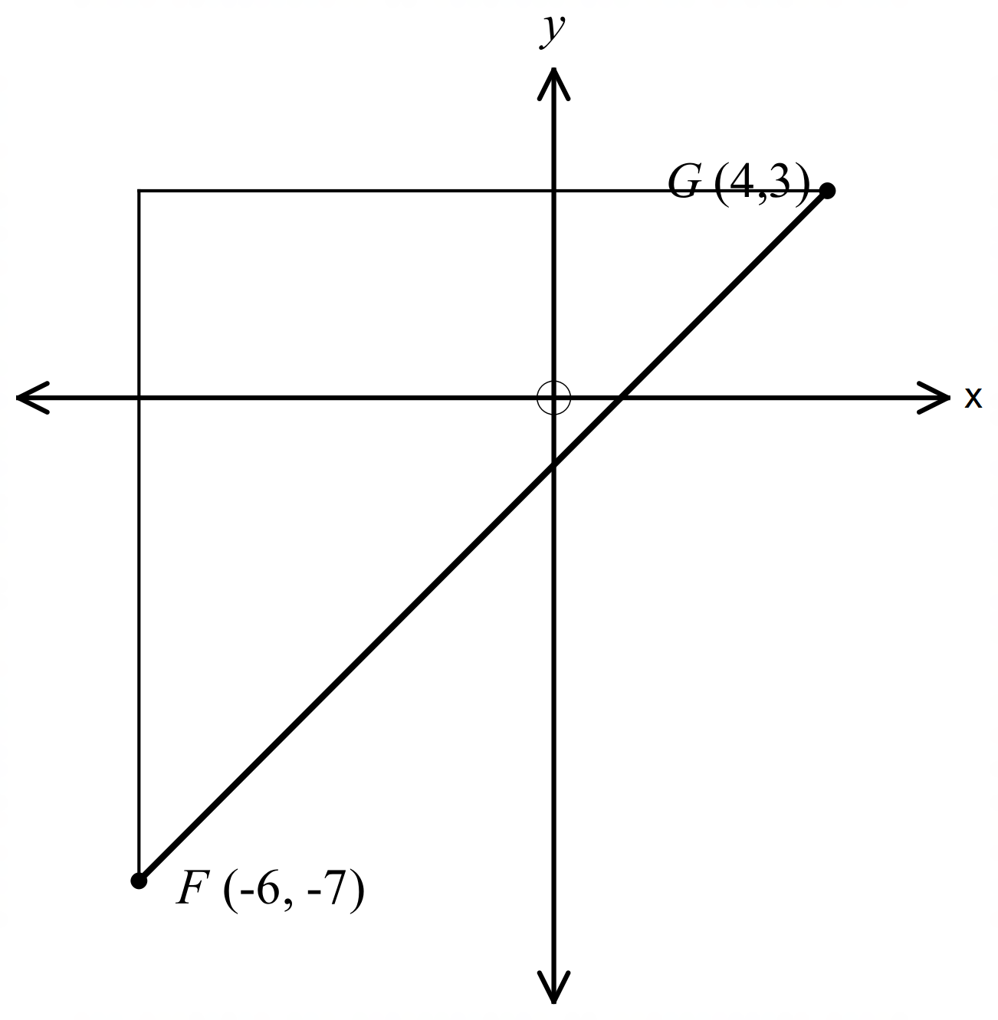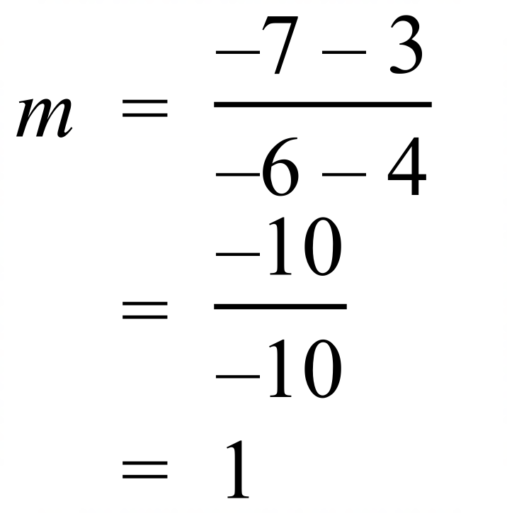 | D
 | 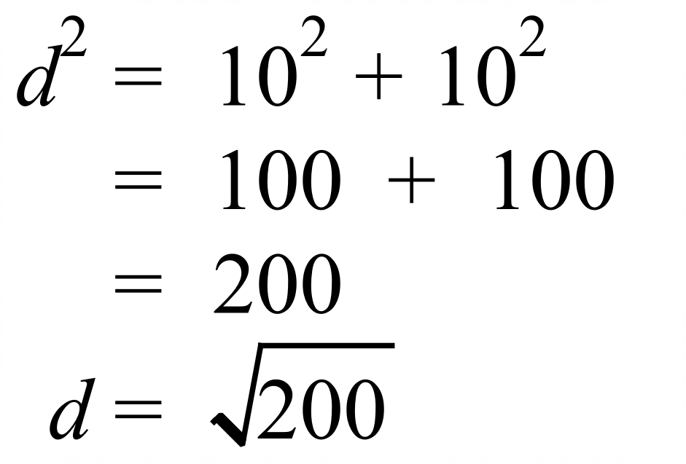 | B
 | T(–6, 4) and U(–9, –2).  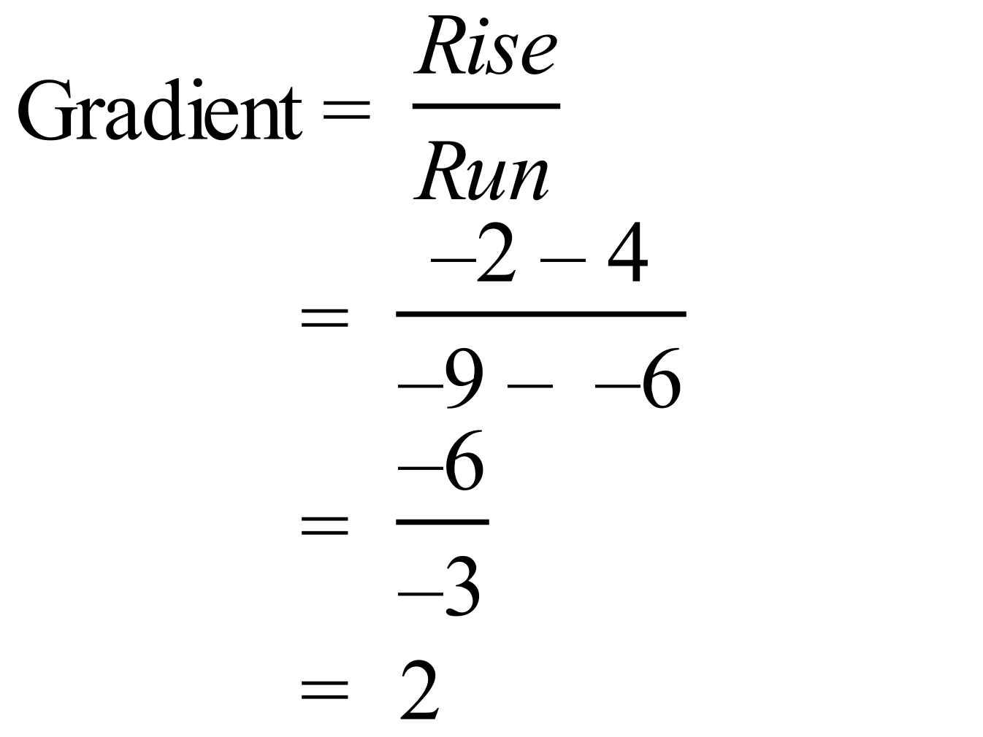 | D
 | D(–6, 1) and E(–5, 8).  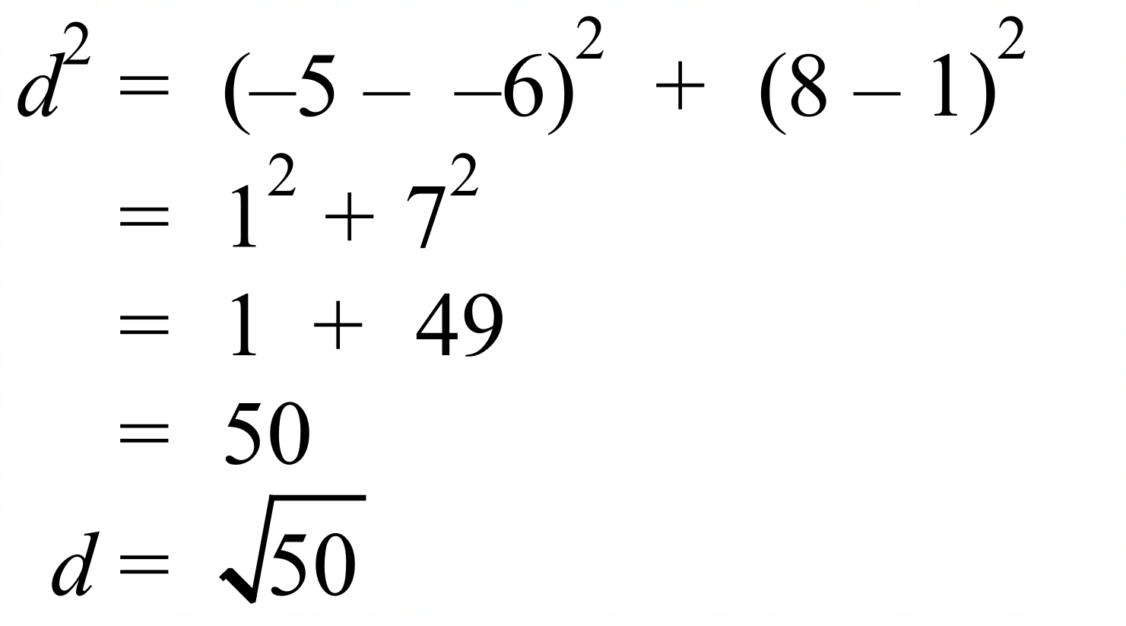 | A
 | 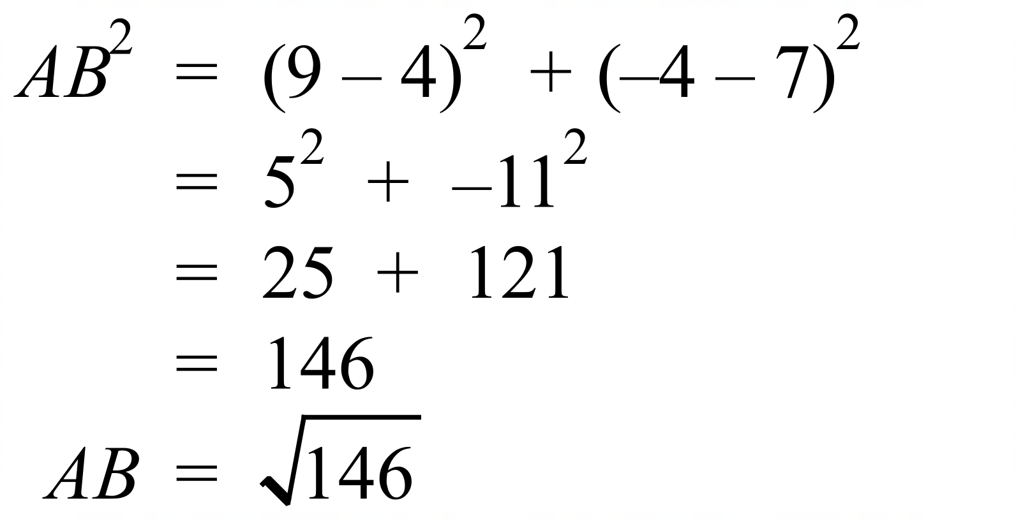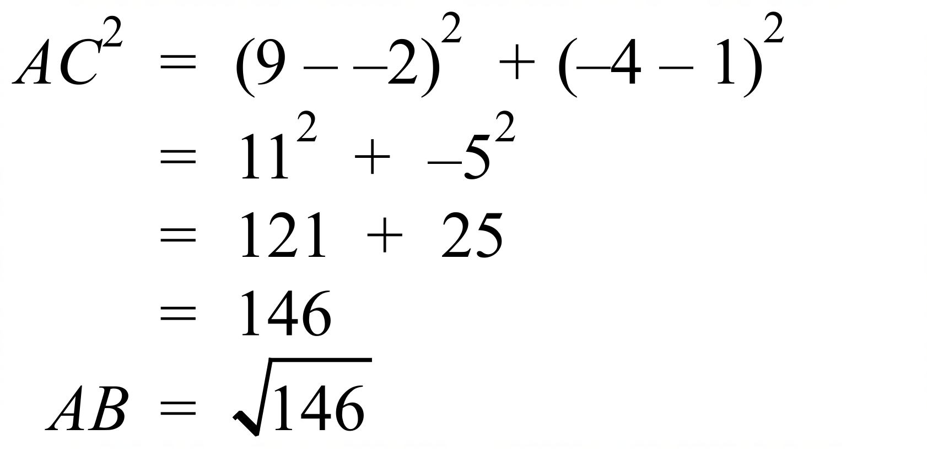  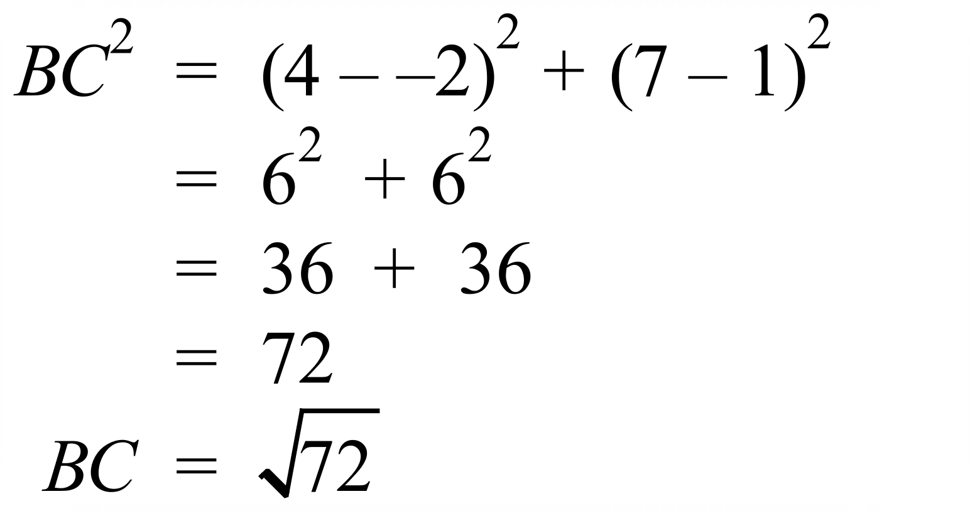  There are two equal sides, and no right angle ( as sum of squares does not obey Pythagoras) only Isosceles applies. | B
 | 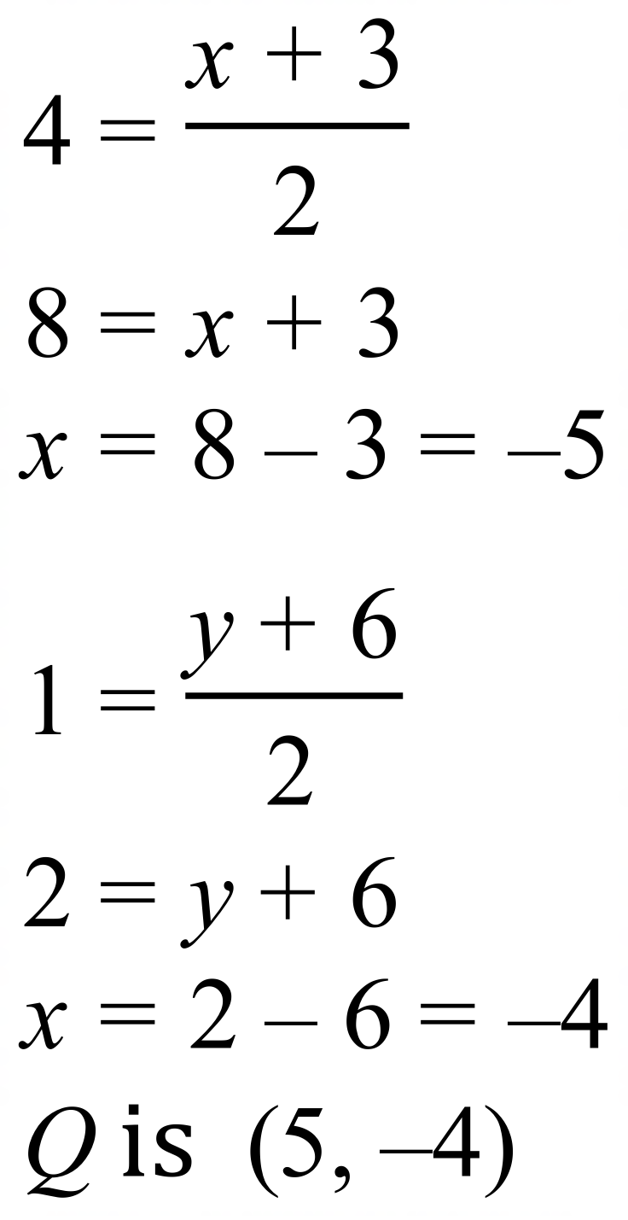 | C
 | 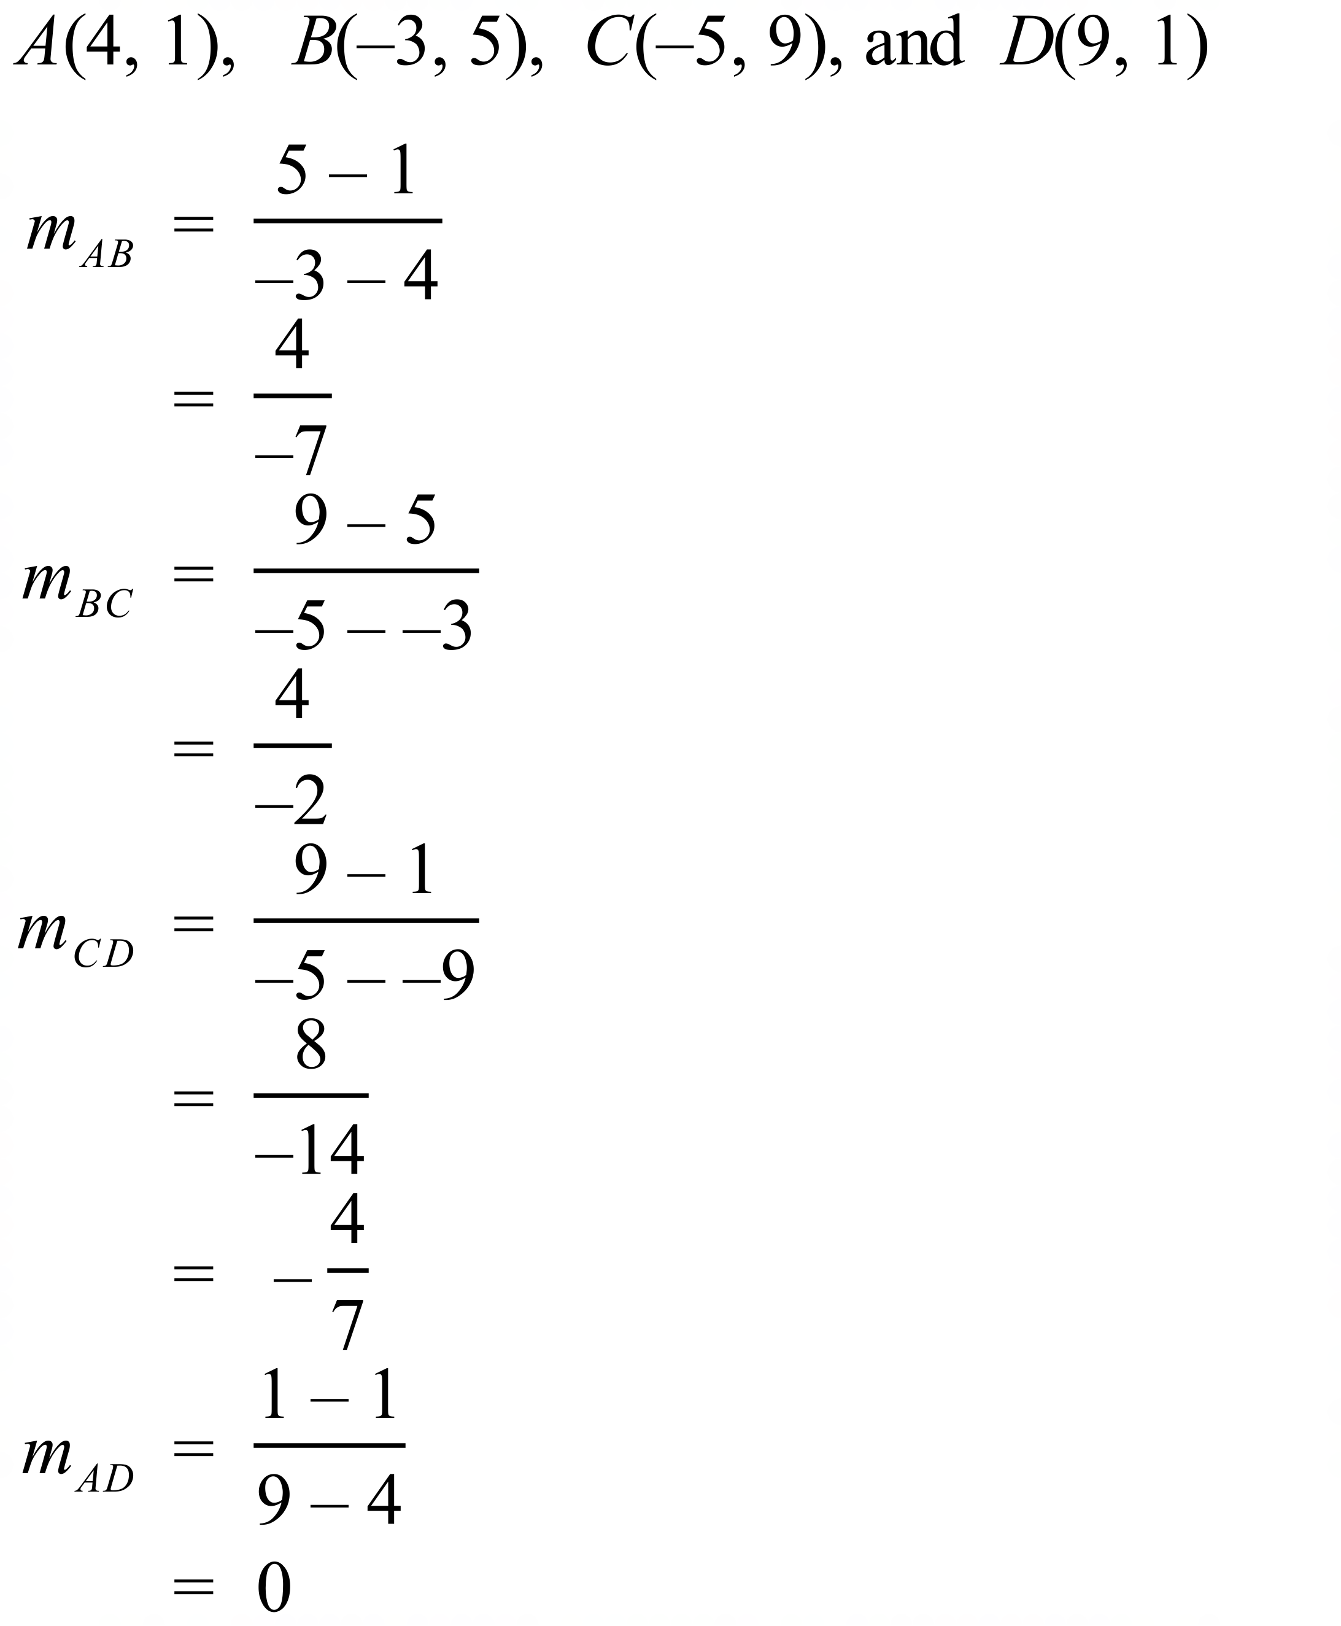  So AB and CD are parallel | A
 | 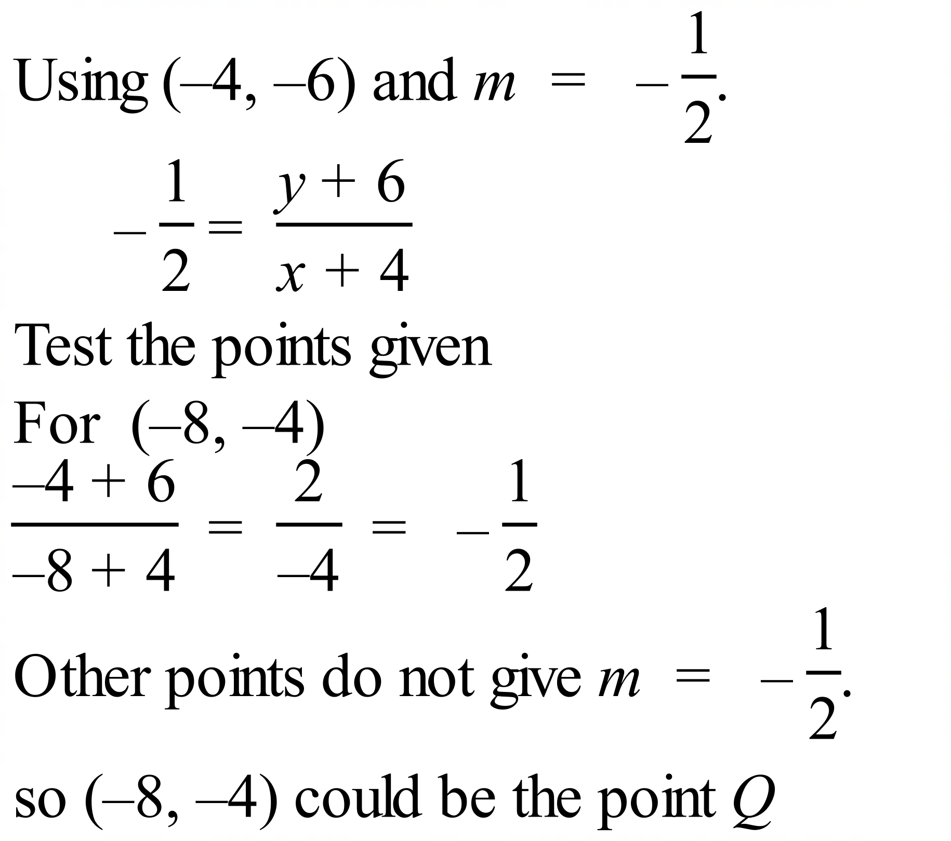 | D
 | 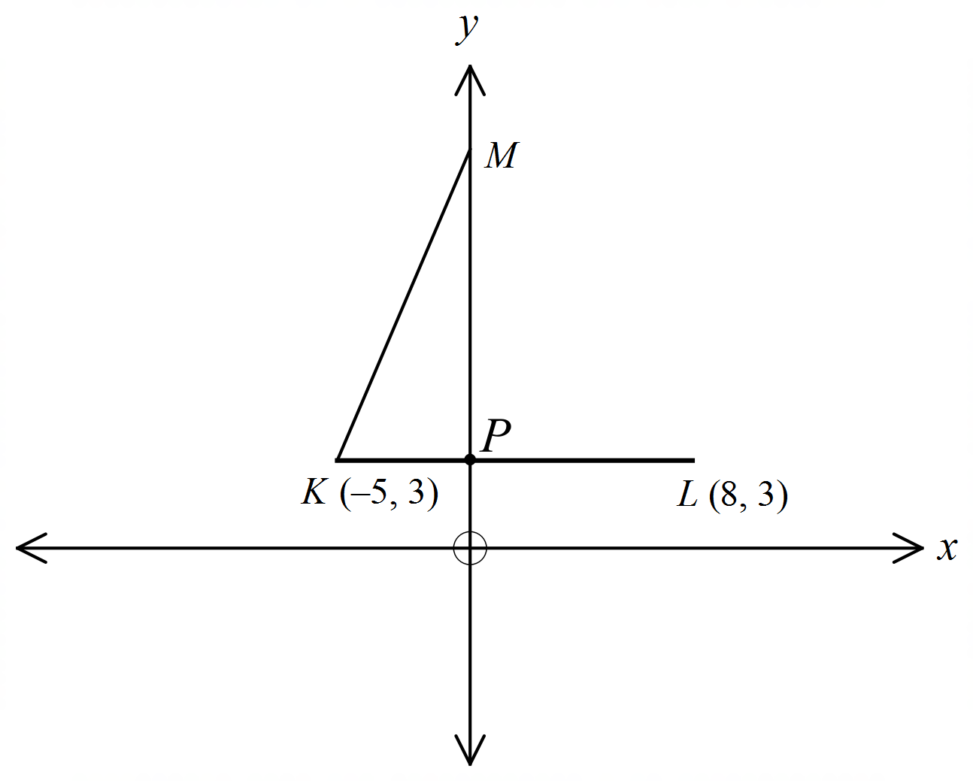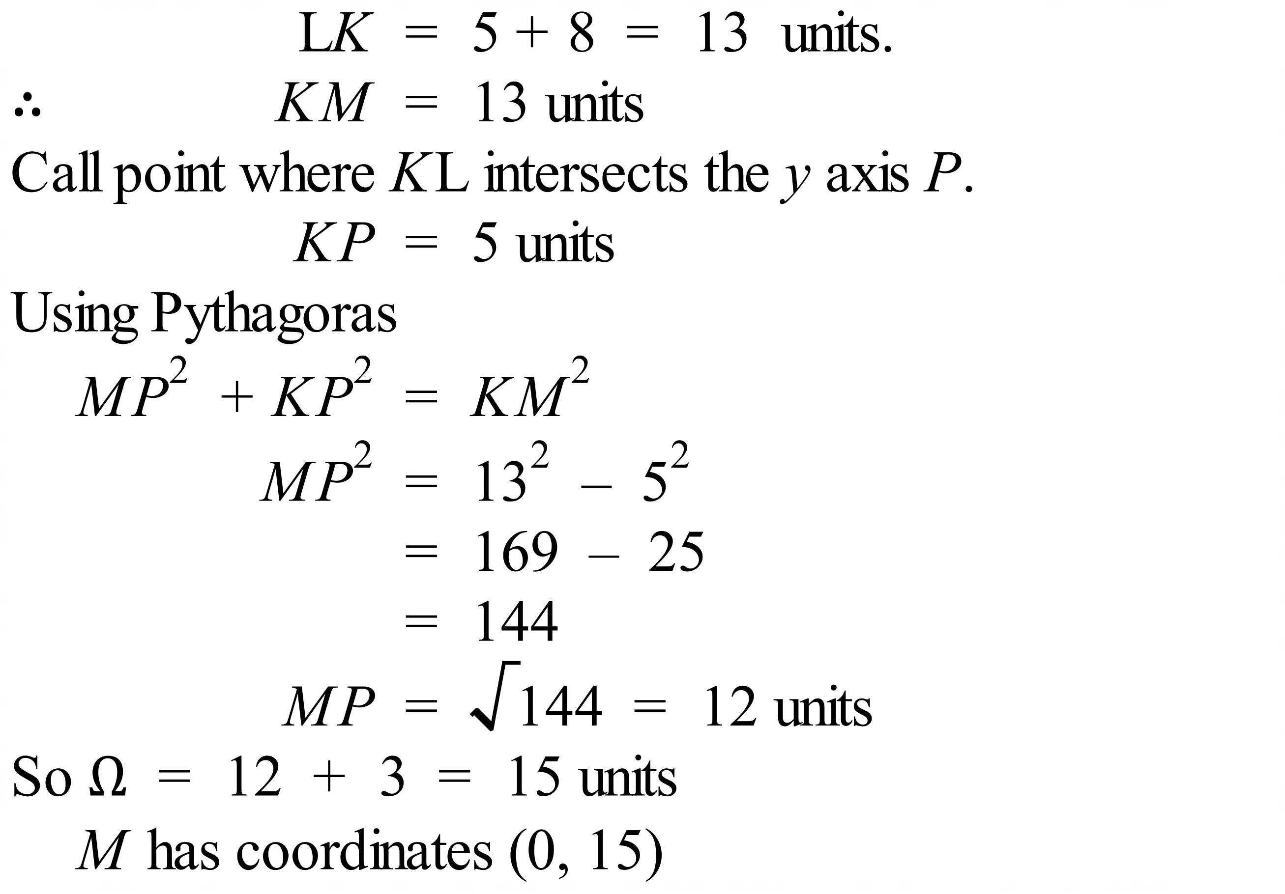 | B

School Name
Mathematics 2017
Multiple Choice Answer Sheet
Coordinate Geometry
Name _____________________________________________
Completely fill the response oval representing the most correct answer.
1. A B C D
2. A B C D
3. A B C D
4. A B C D
5. A B C D
6. A B C D
7. A B C D
8. A B C D
9. A B C D
10. A B C D
11. A B C D
12. A B C D
13. A B C D
14. A B C D
15. A B C D

